**Open Source Project / Repository Details –**

Link to student login account on GitHub: <https://github.com/HarshwardhanChougule45>

List of Open Source projects selected for observation / navigation:

* NodeJs
* Angular

**Project 1 (https://github.com/nodejs/node):**

**Project Details:**

Node.js is an open-source, server-side runtime environment that allows you to execute JavaScript code on the server. It was created by Ryan Dahl and initially released in 2009. Node.js is built on the Chrome V8 JavaScript engine, which is known for its speed and efficiency. Here are some key details about Node.js:

1. JavaScript on the Server: Node.js enables developers to use JavaScript for both client-side and server-side development. This unification of programming languages can streamline development and make it easier to share code between the front end and back end of a web application.
2. Non-blocking, Asynchronous I/O: Node.js uses an event-driven, non-blocking I/O model, which allows it to handle a large number of concurrent connections efficiently. This is particularly well-suited for applications that require real-time features, such as chat applications or online gaming.
3. NPM (Node Package Manager): NPM is the default package manager for Node.js. It provides access to a vast ecosystem of open-source libraries and packages that simplify development tasks. Developers can easily install, manage, and share packages through NPM.
4. Single-Threaded, Event Loop: Node.js uses a single-threaded event loop to handle asynchronous operations. While this can simplify development, it's important to note that CPU-intensive tasks can block the event loop and should be handled with care.
5. Cross-Platform: Node.js is designed to work on multiple operating systems, including Windows, macOS, and various Linux distributions. This cross-platform compatibility makes it versatile for building applications that can run on a wide range of servers.
6. Scalability: Node.js is known for its ability to scale horizontally by adding more servers to handle increased load. This makes it suitable for building scalable and high-performance applications.
7. Community and Ecosystem: Node.js has a large and active community of developers, which means there are plenty of resources, tutorials, and libraries available to help with development. Additionally, many major companies, such as Netflix, PayPal, and LinkedIn, use Node.js for their applications.
8. Security: While Node.js itself is secure, developers need to follow best practices for secure coding and use packages from trusted sources. Security vulnerabilities can arise from poorly written code or outdated packages.
9. Web Frameworks: Node.js has a variety of web frameworks and libraries, such as Express.js, Hapi.js, and Nest.js, that simplify the process of building web applications and APIs.
10. Real-Time Applications: Node.js is commonly used for building real-time applications like chat applications, online gaming servers, and collaborative tools due to its event-driven architecture and low latency.

Node.js has become a popular choice for web and server-side development, and its ecosystem continues to grow with new tools and frameworks. Developers can leverage its strengths to build efficient, scalable, and high-performance applications.

**Top of Form**

**Bottom of Form**

Total number of contributors:

List of top 5 contributors:

* <<contributor 1, with images of top 5 open and closed pull requests by them, with observations>>

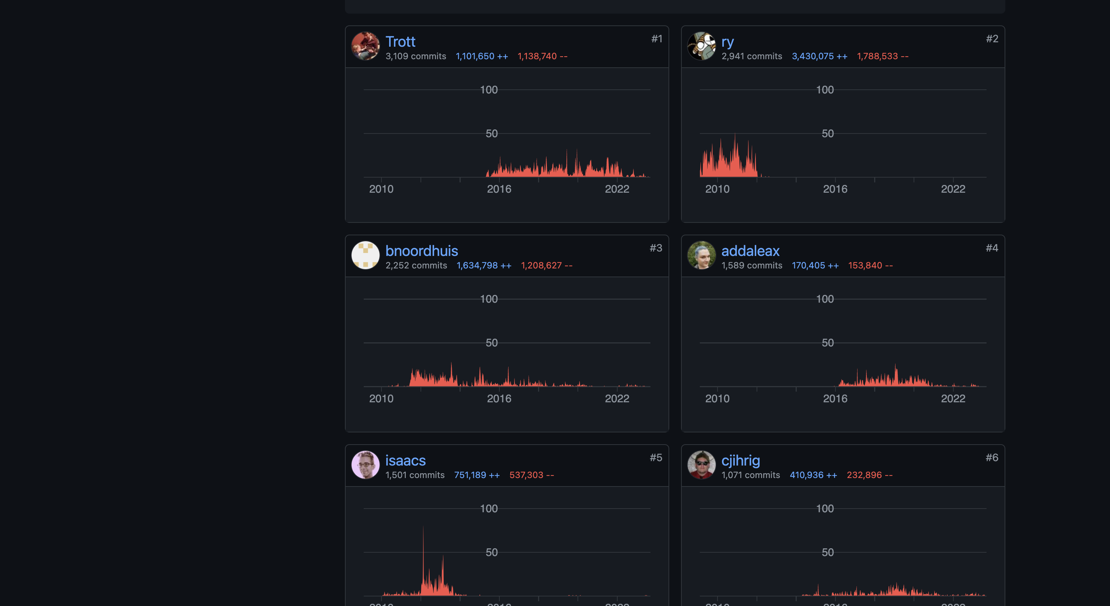

Closed pull request by Trott

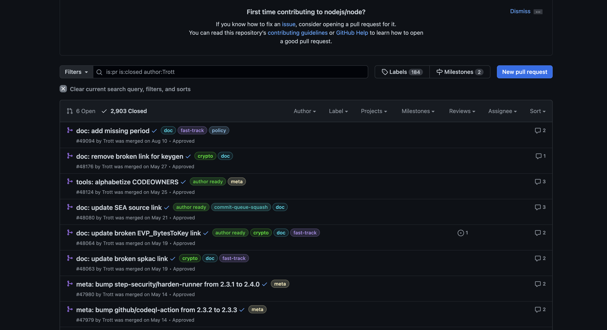

Open pull request by Trott

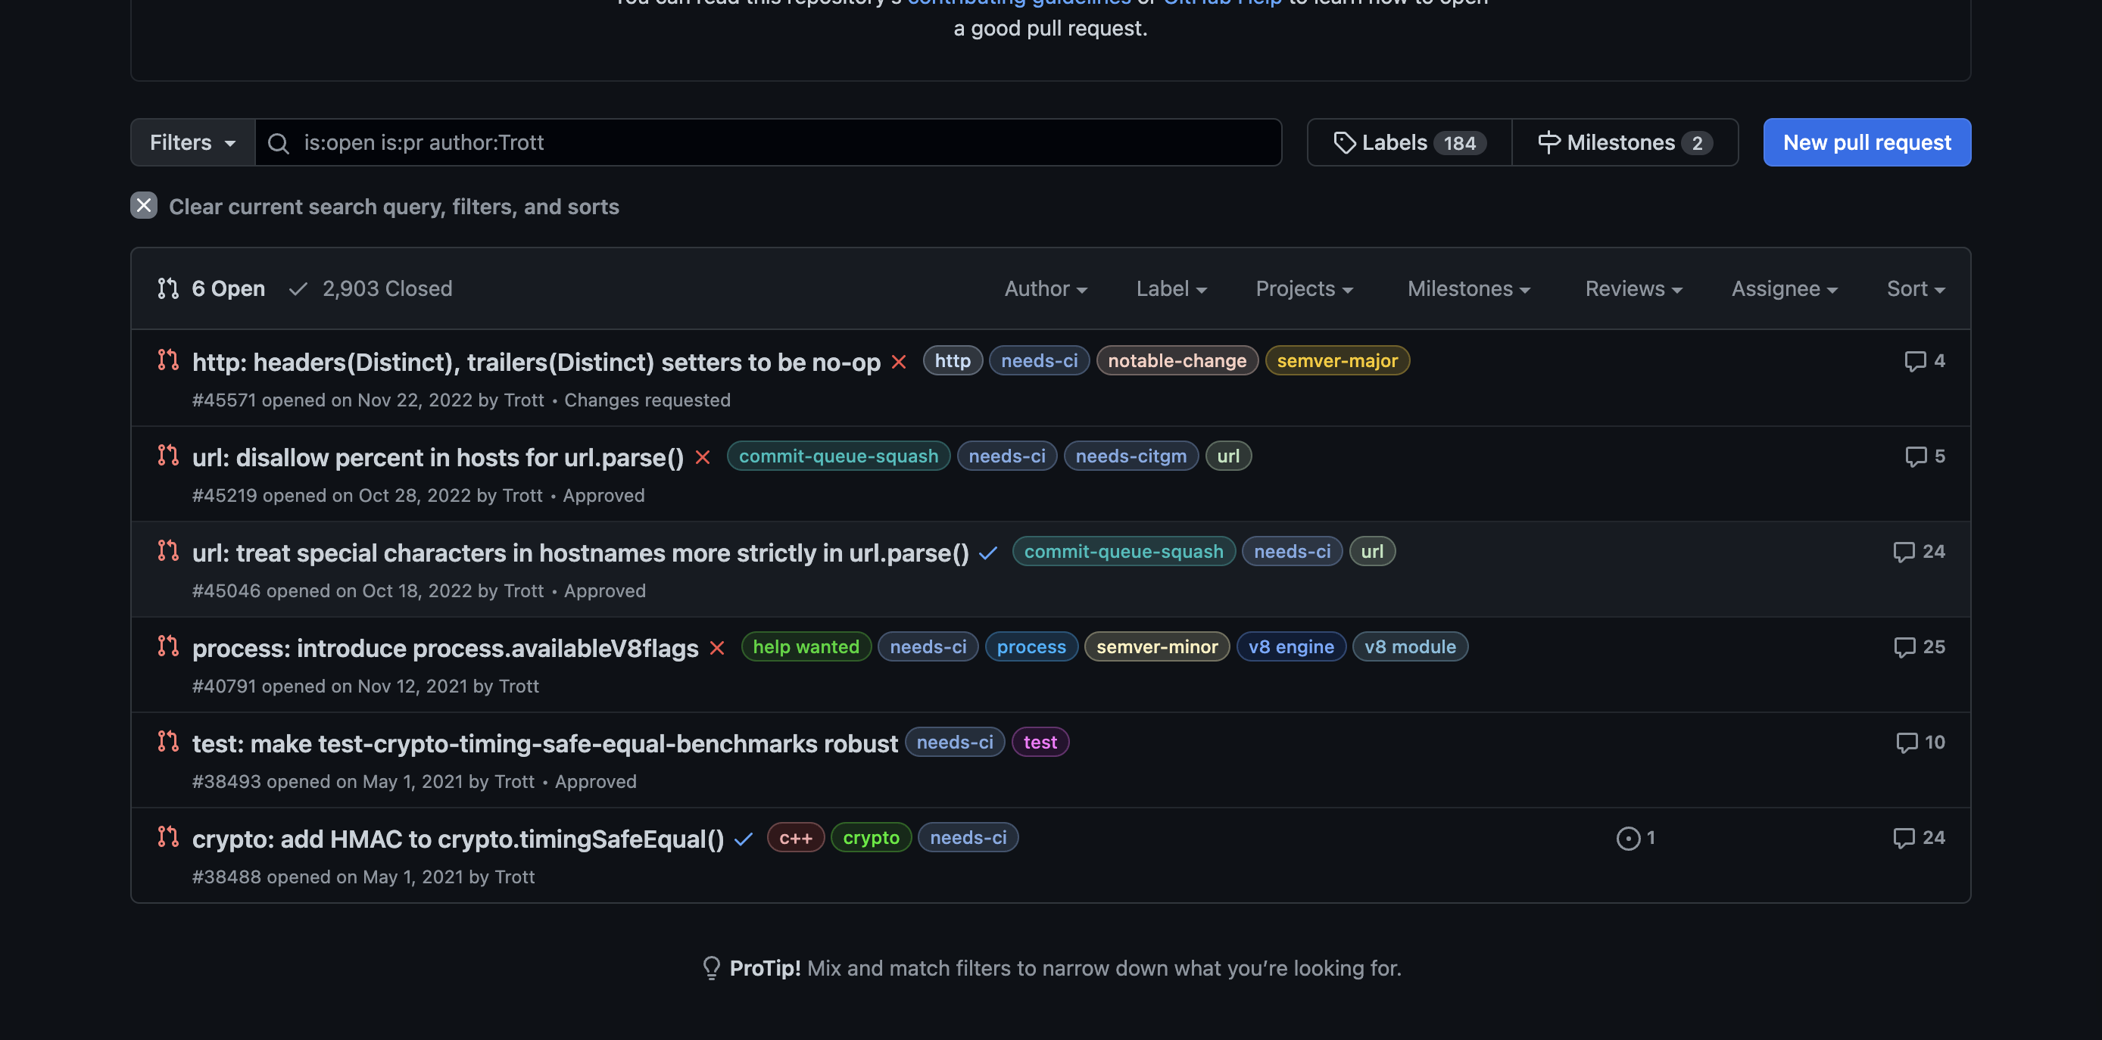

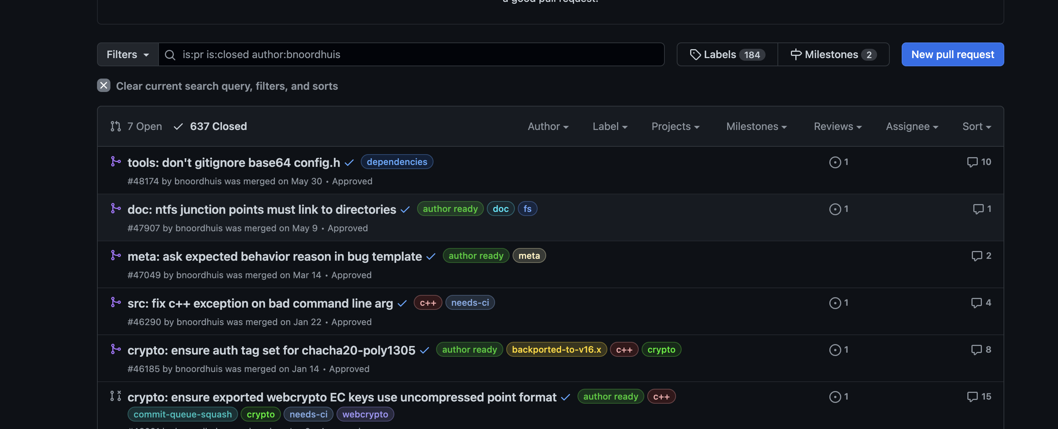

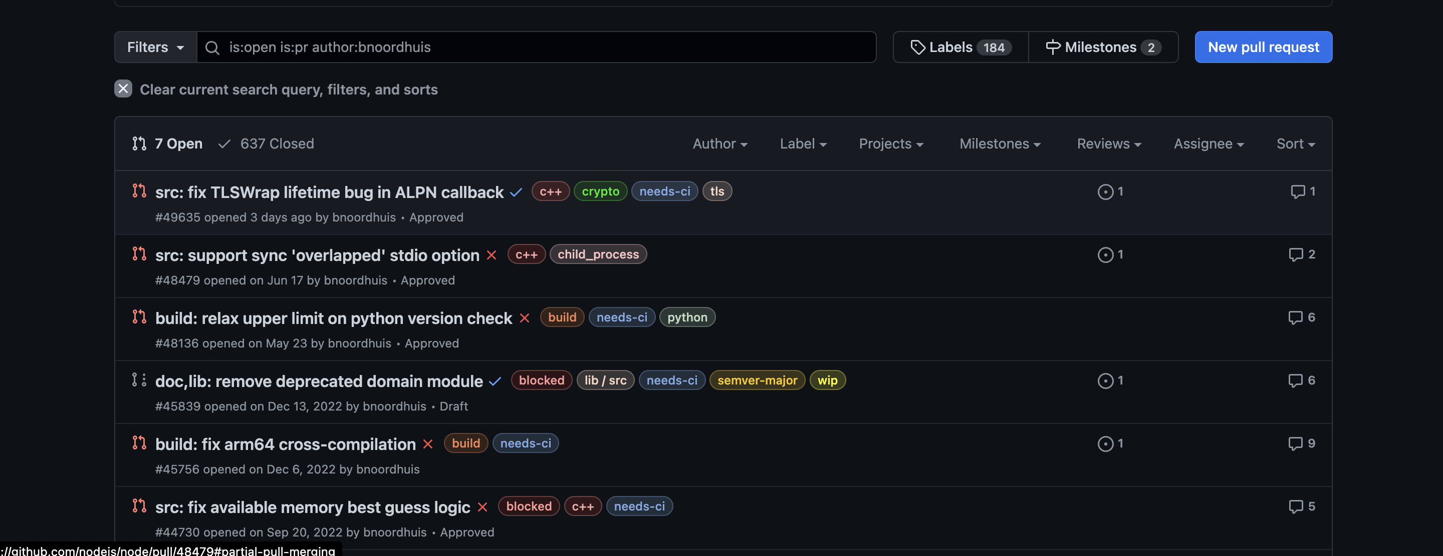

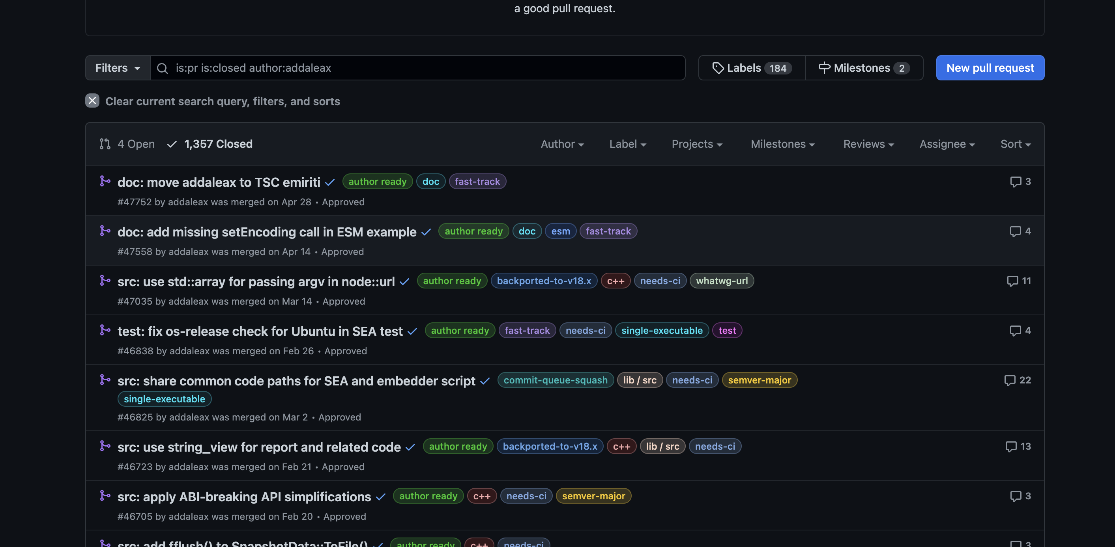

Details of pull requests (open and closed):

Closed:-

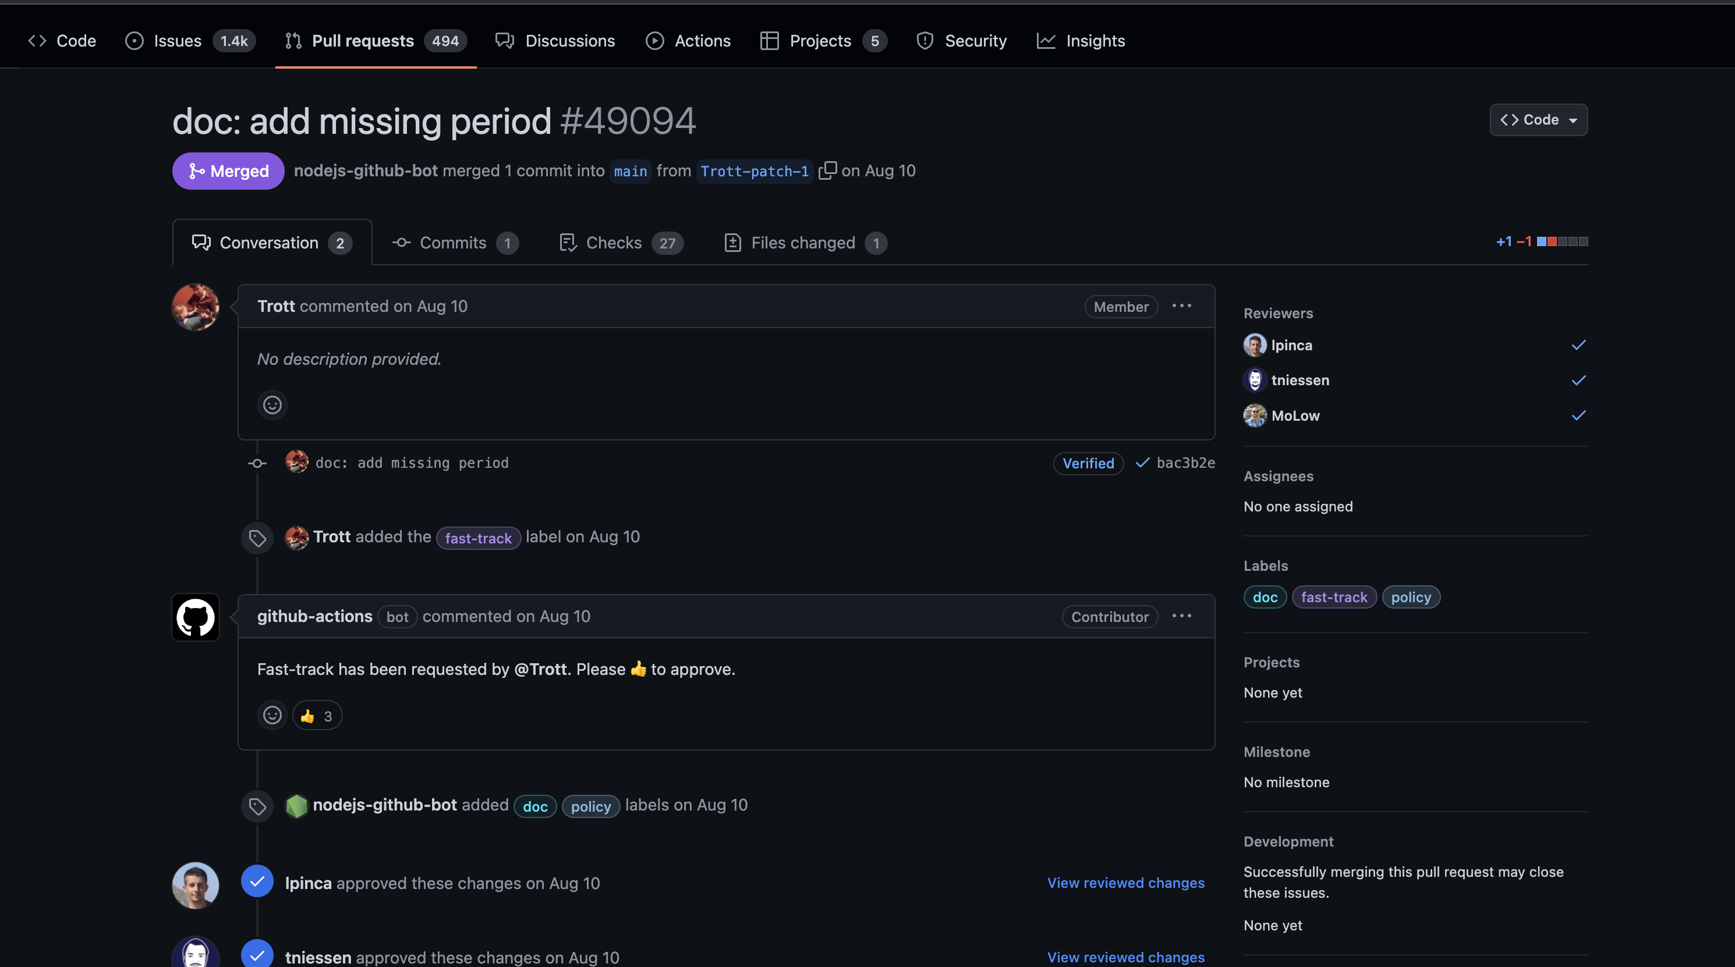

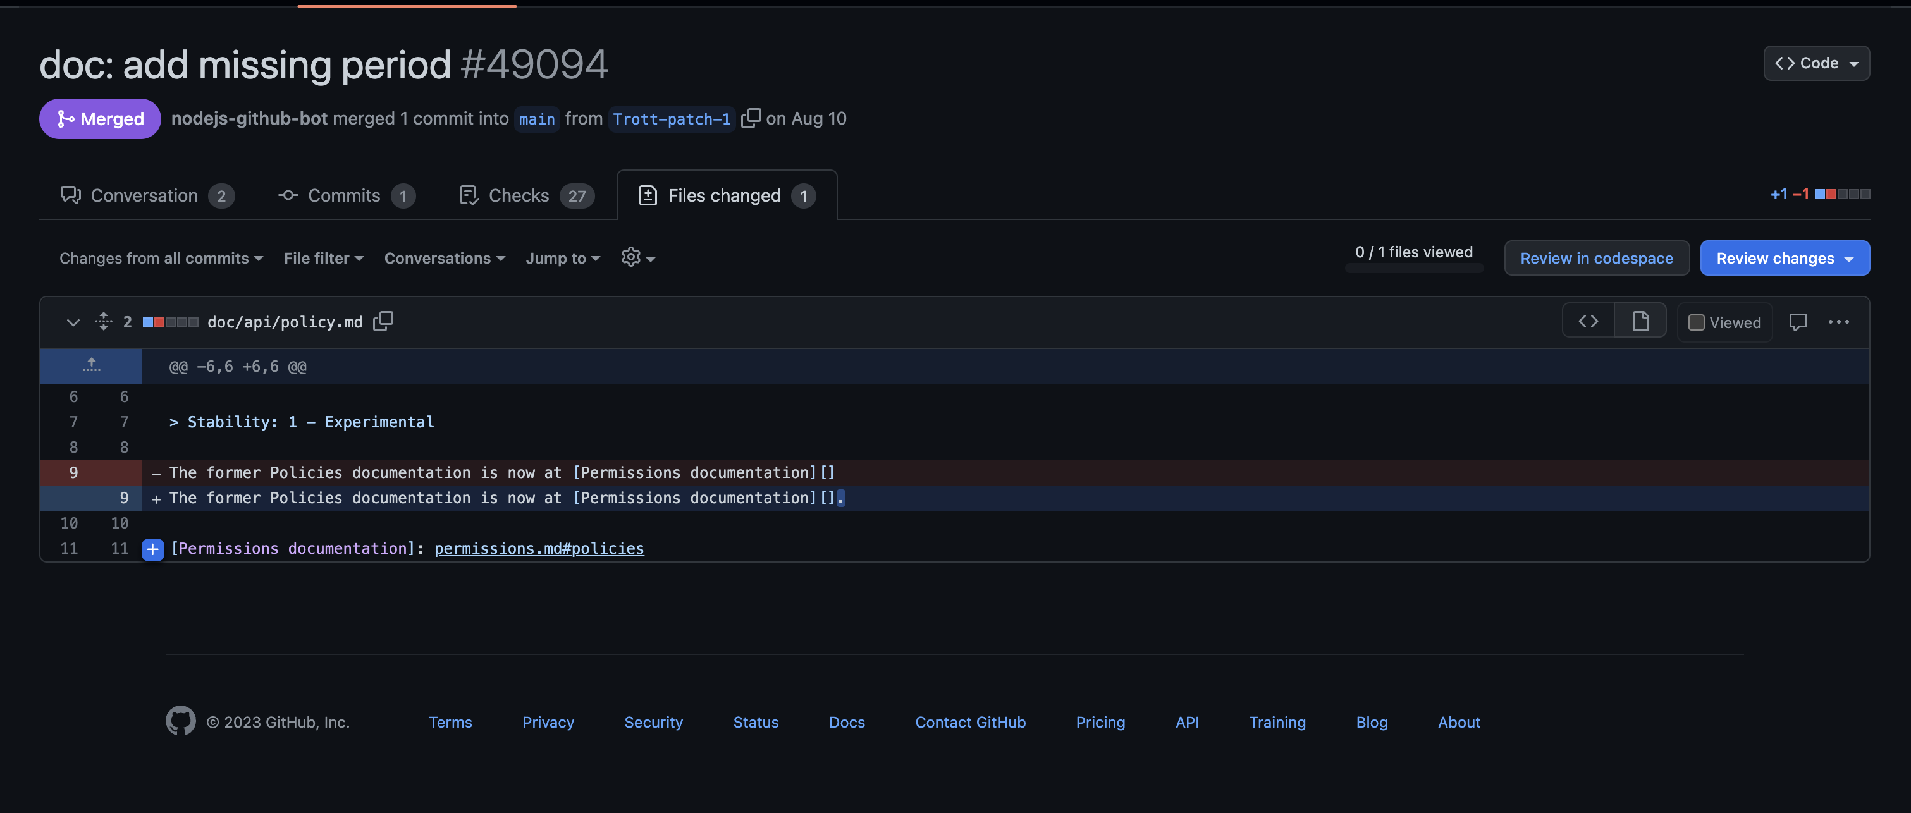

Open:-

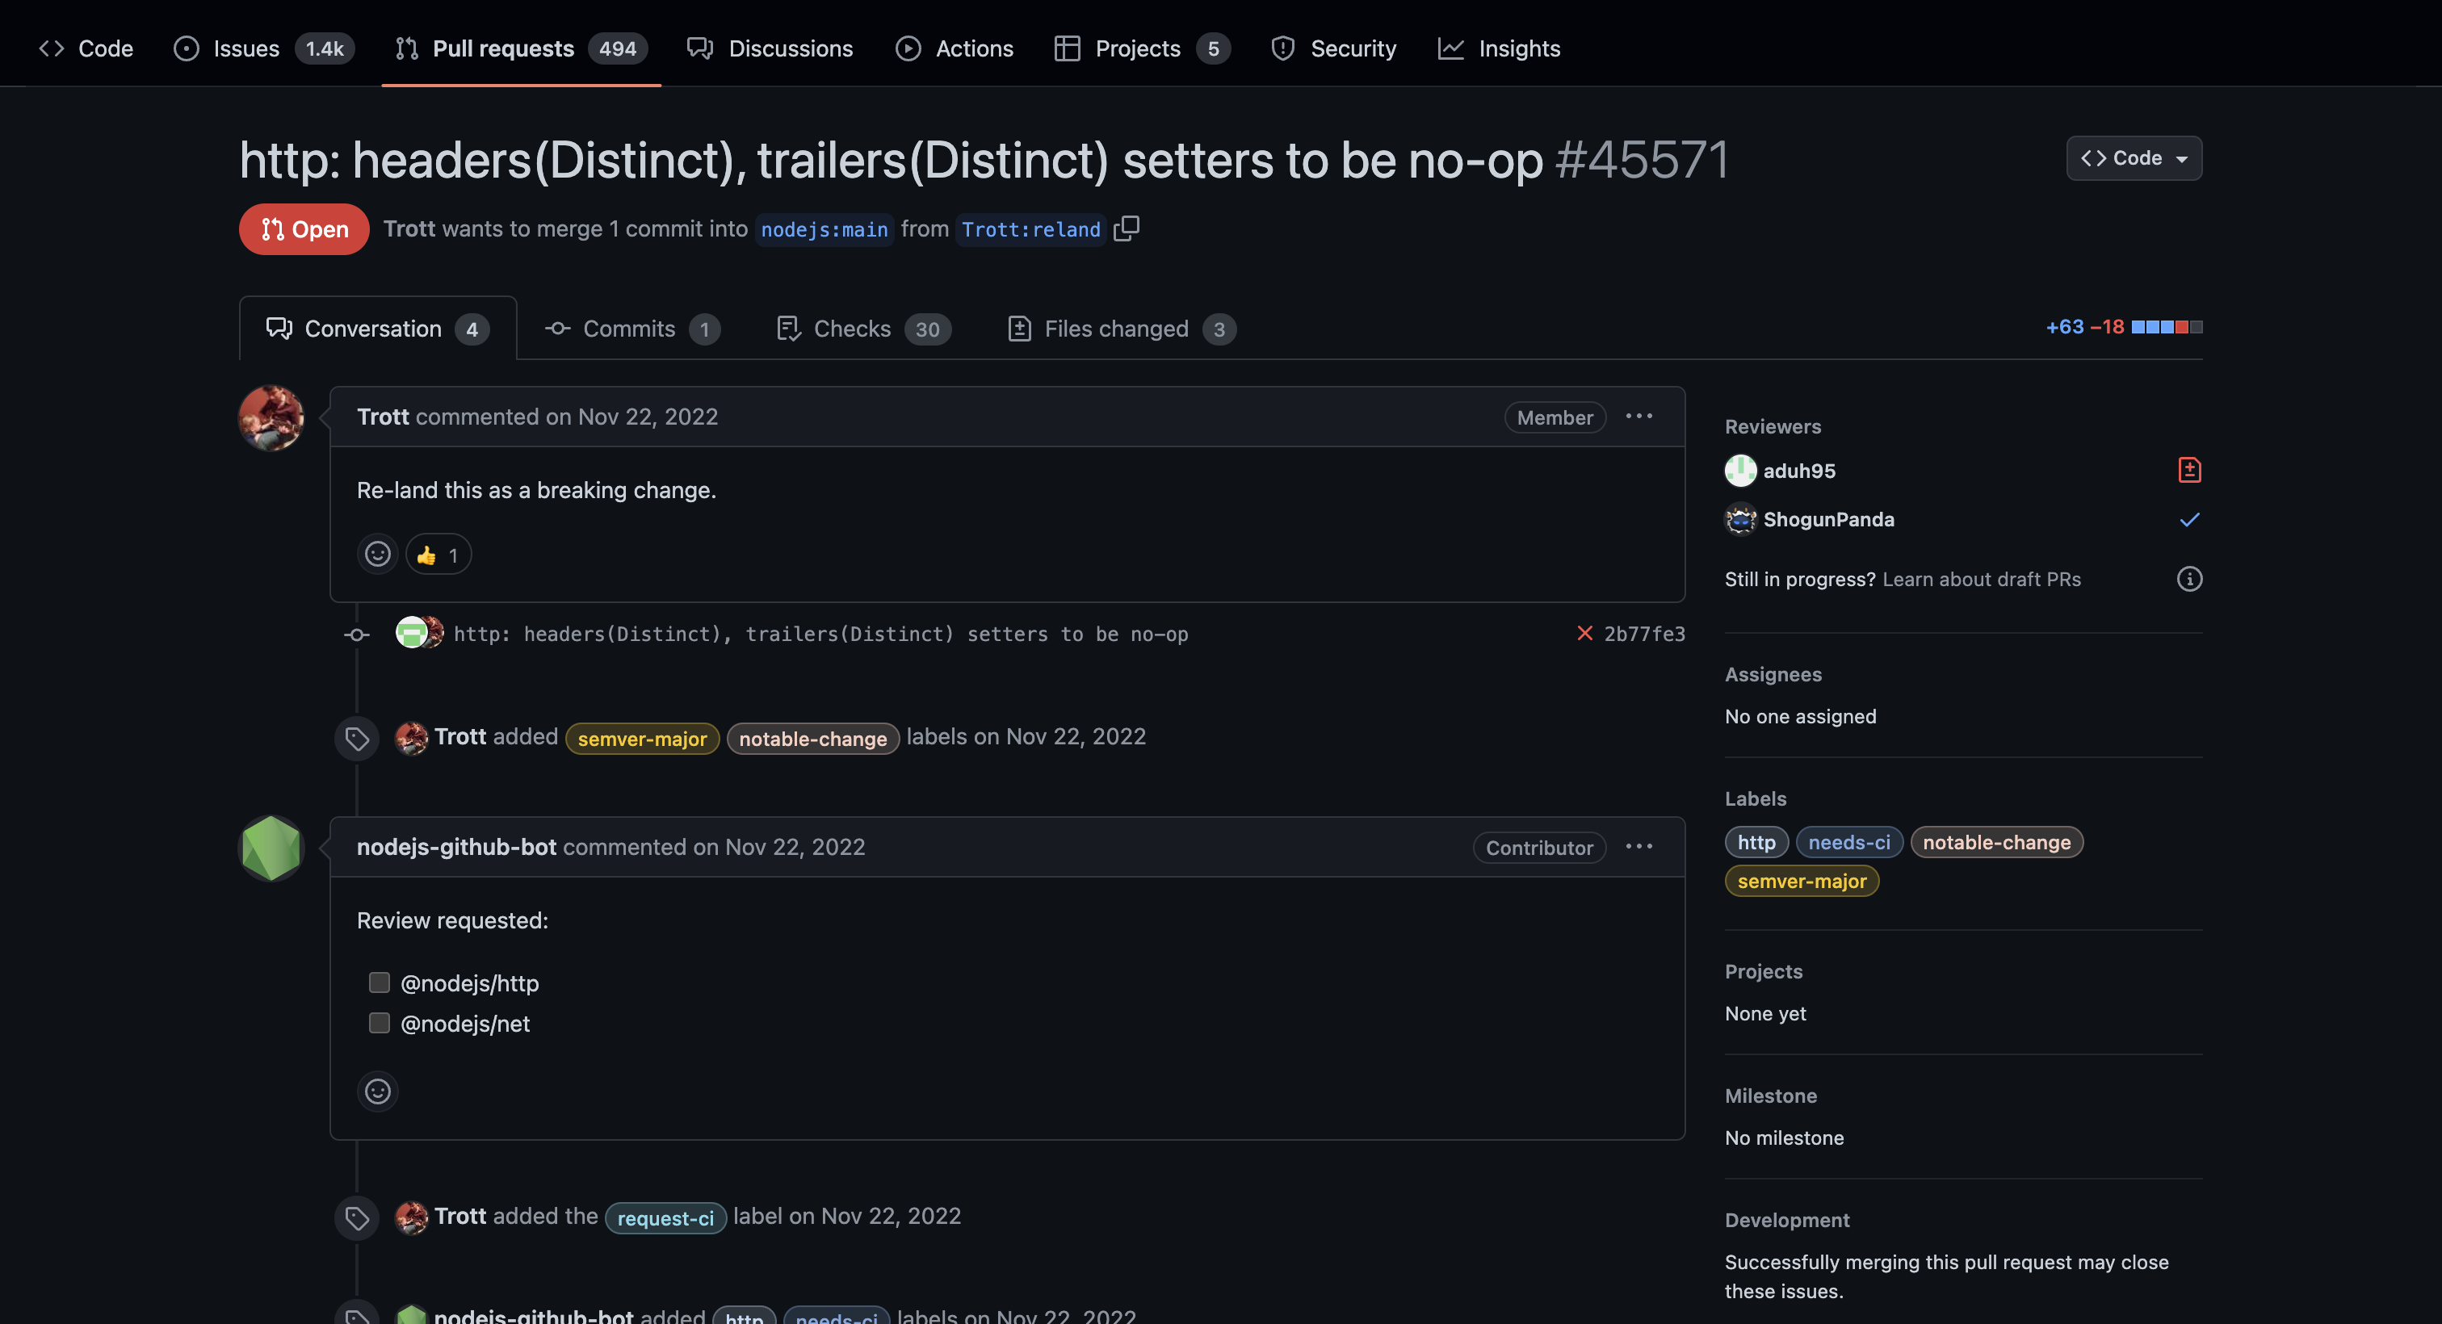

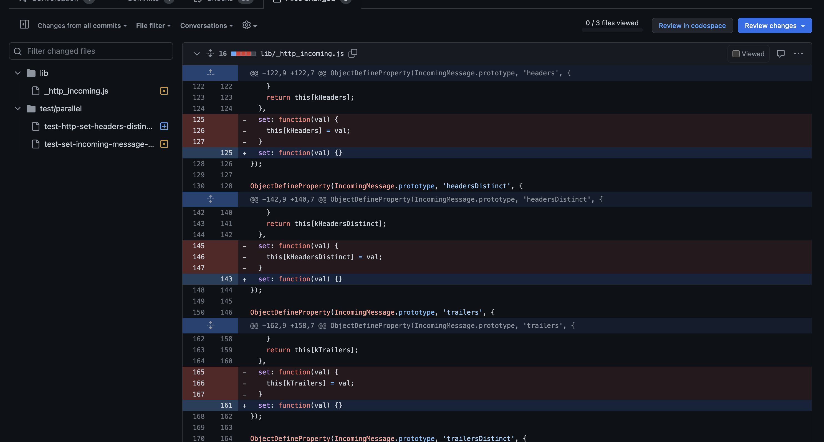

List the most recent 5 Open Pull Requests:

* <<Open pull request 1, with snapshot of files modified, types of modifications proposed, comments by contributor and admin, along with your observations>>

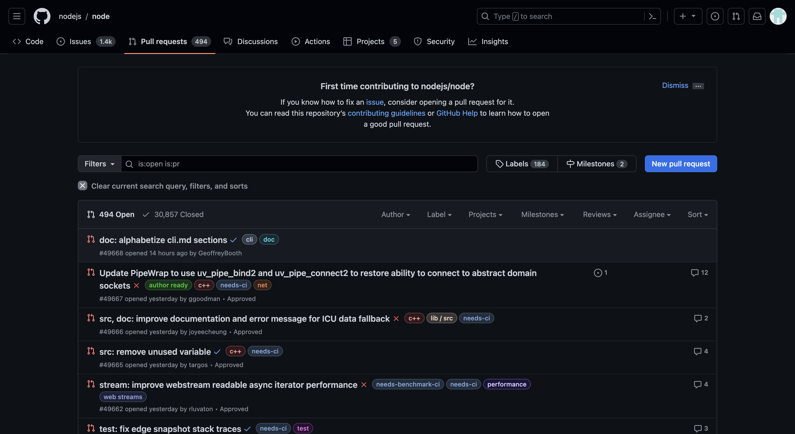

1.

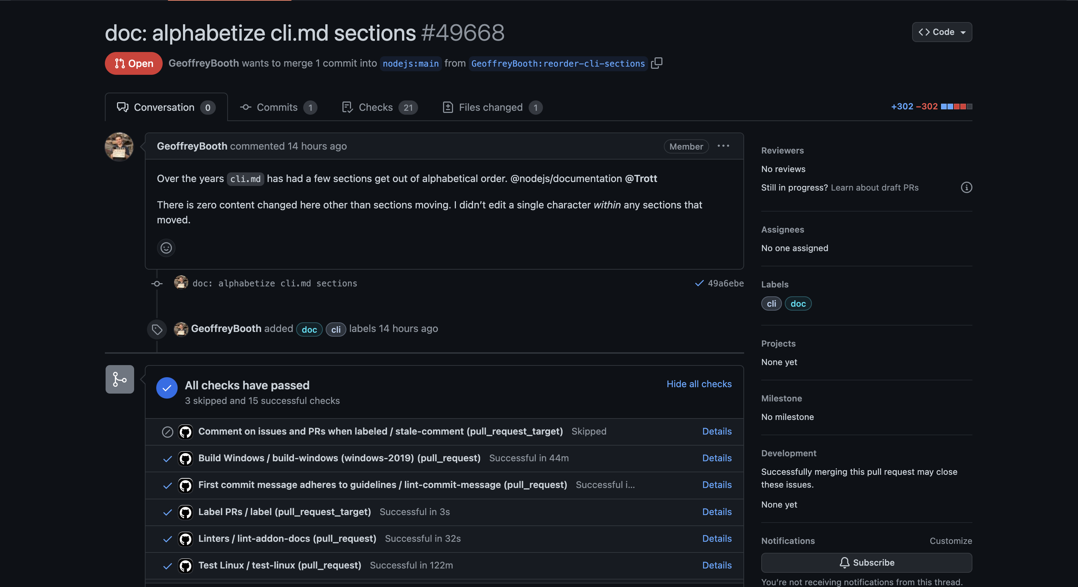

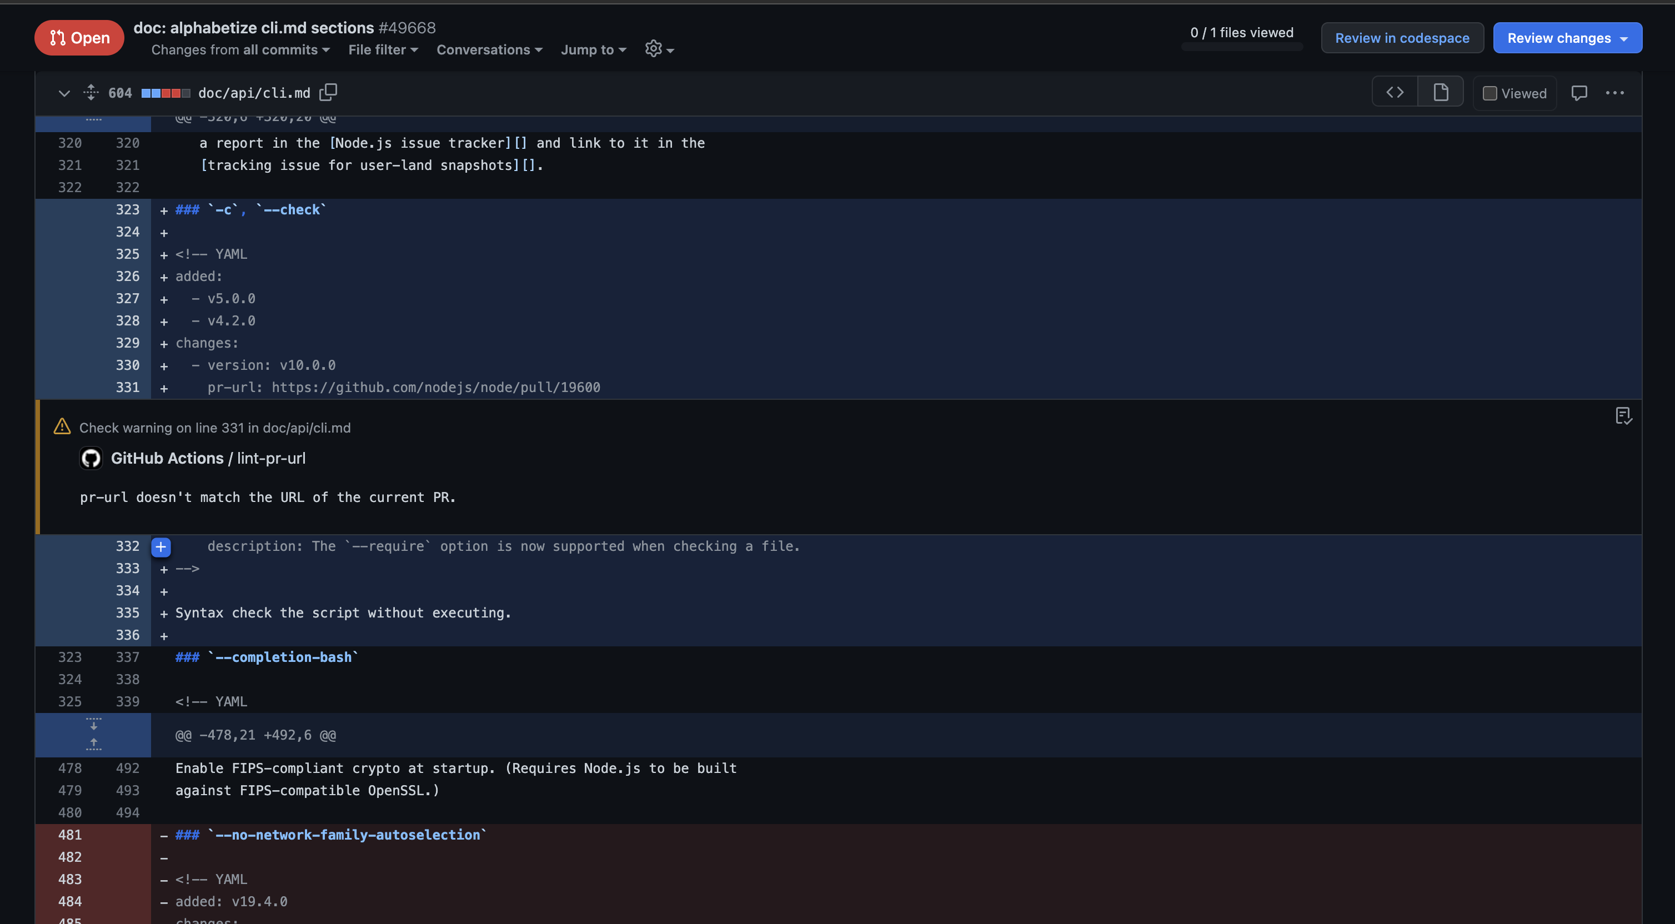

2. 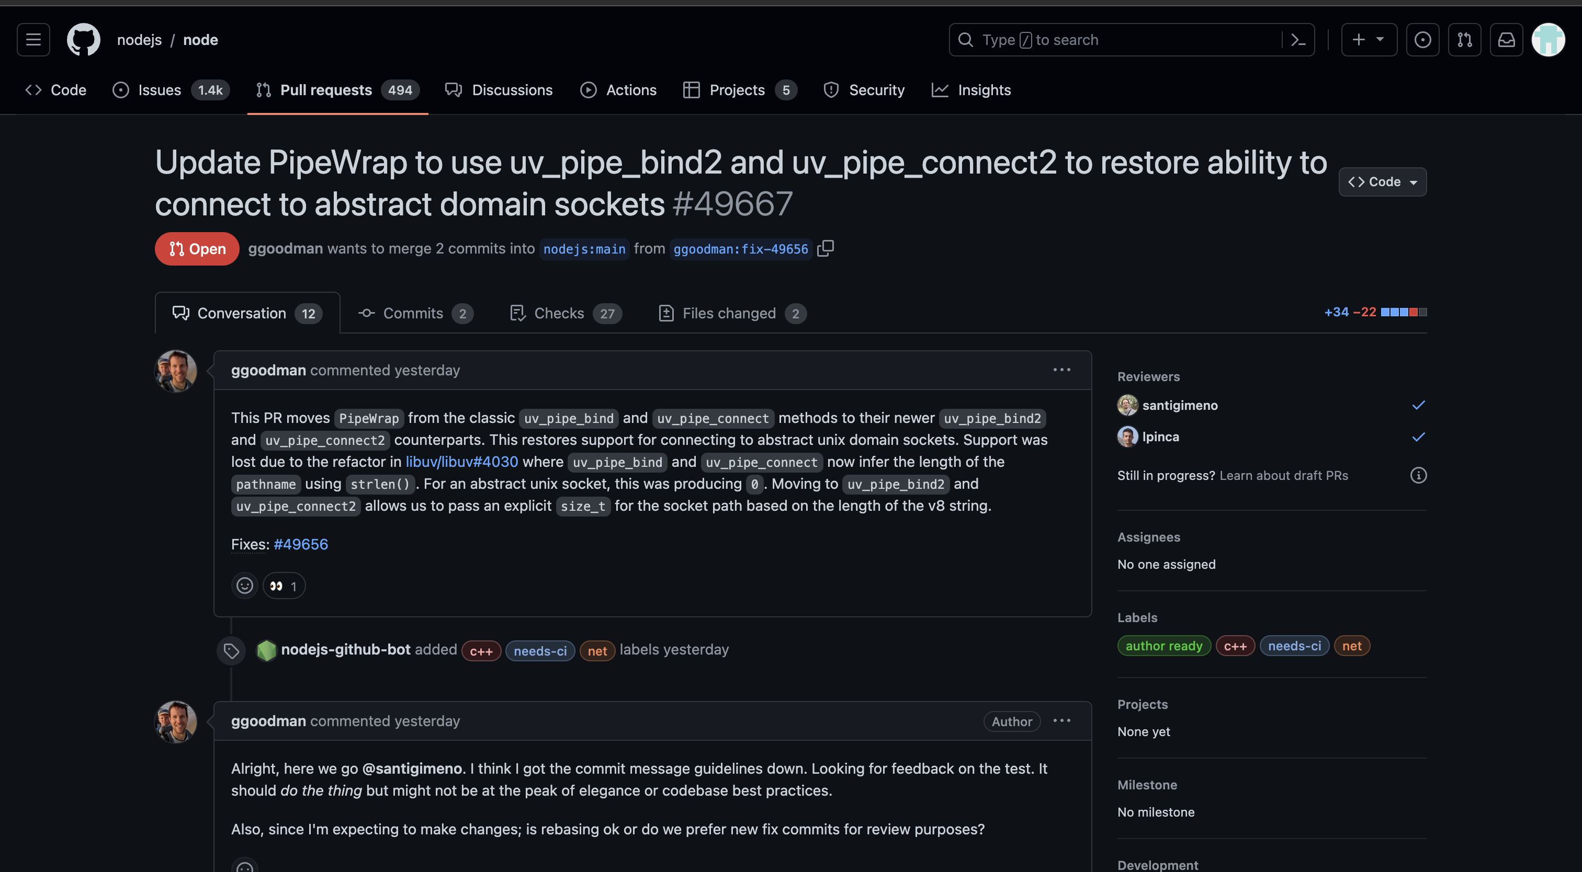

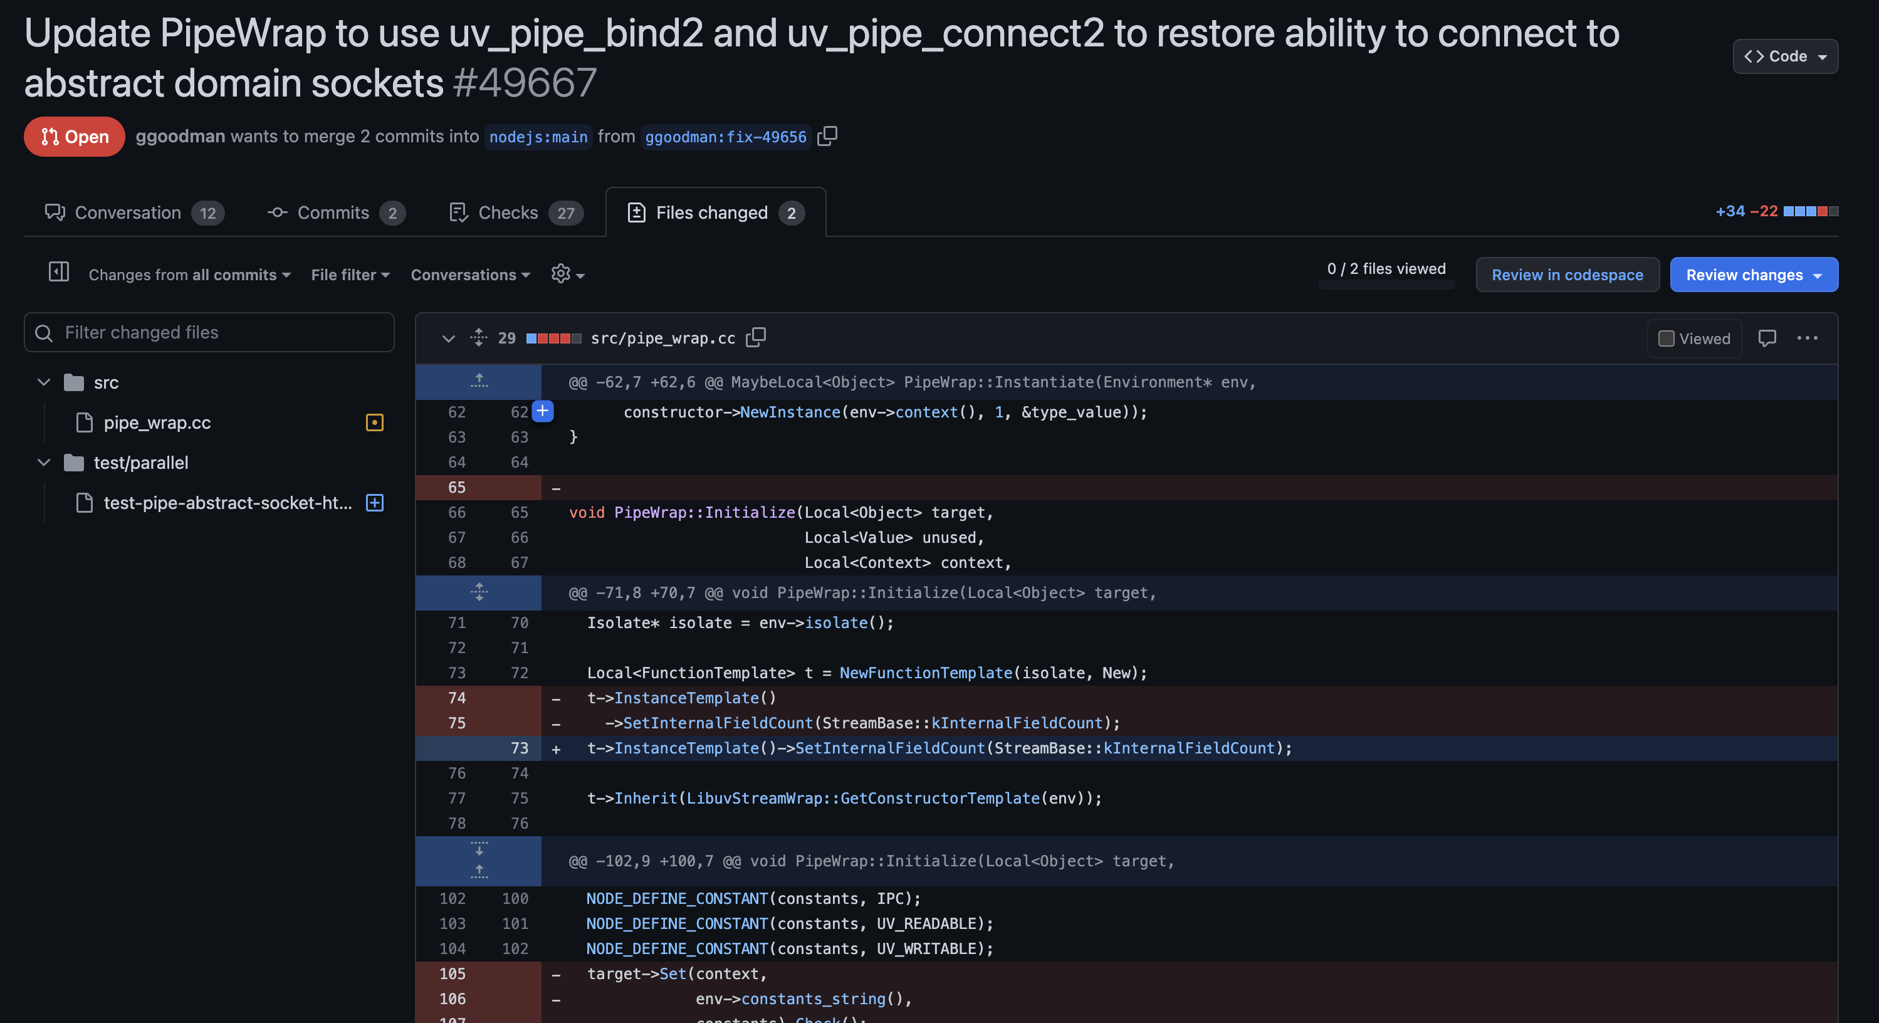

3.

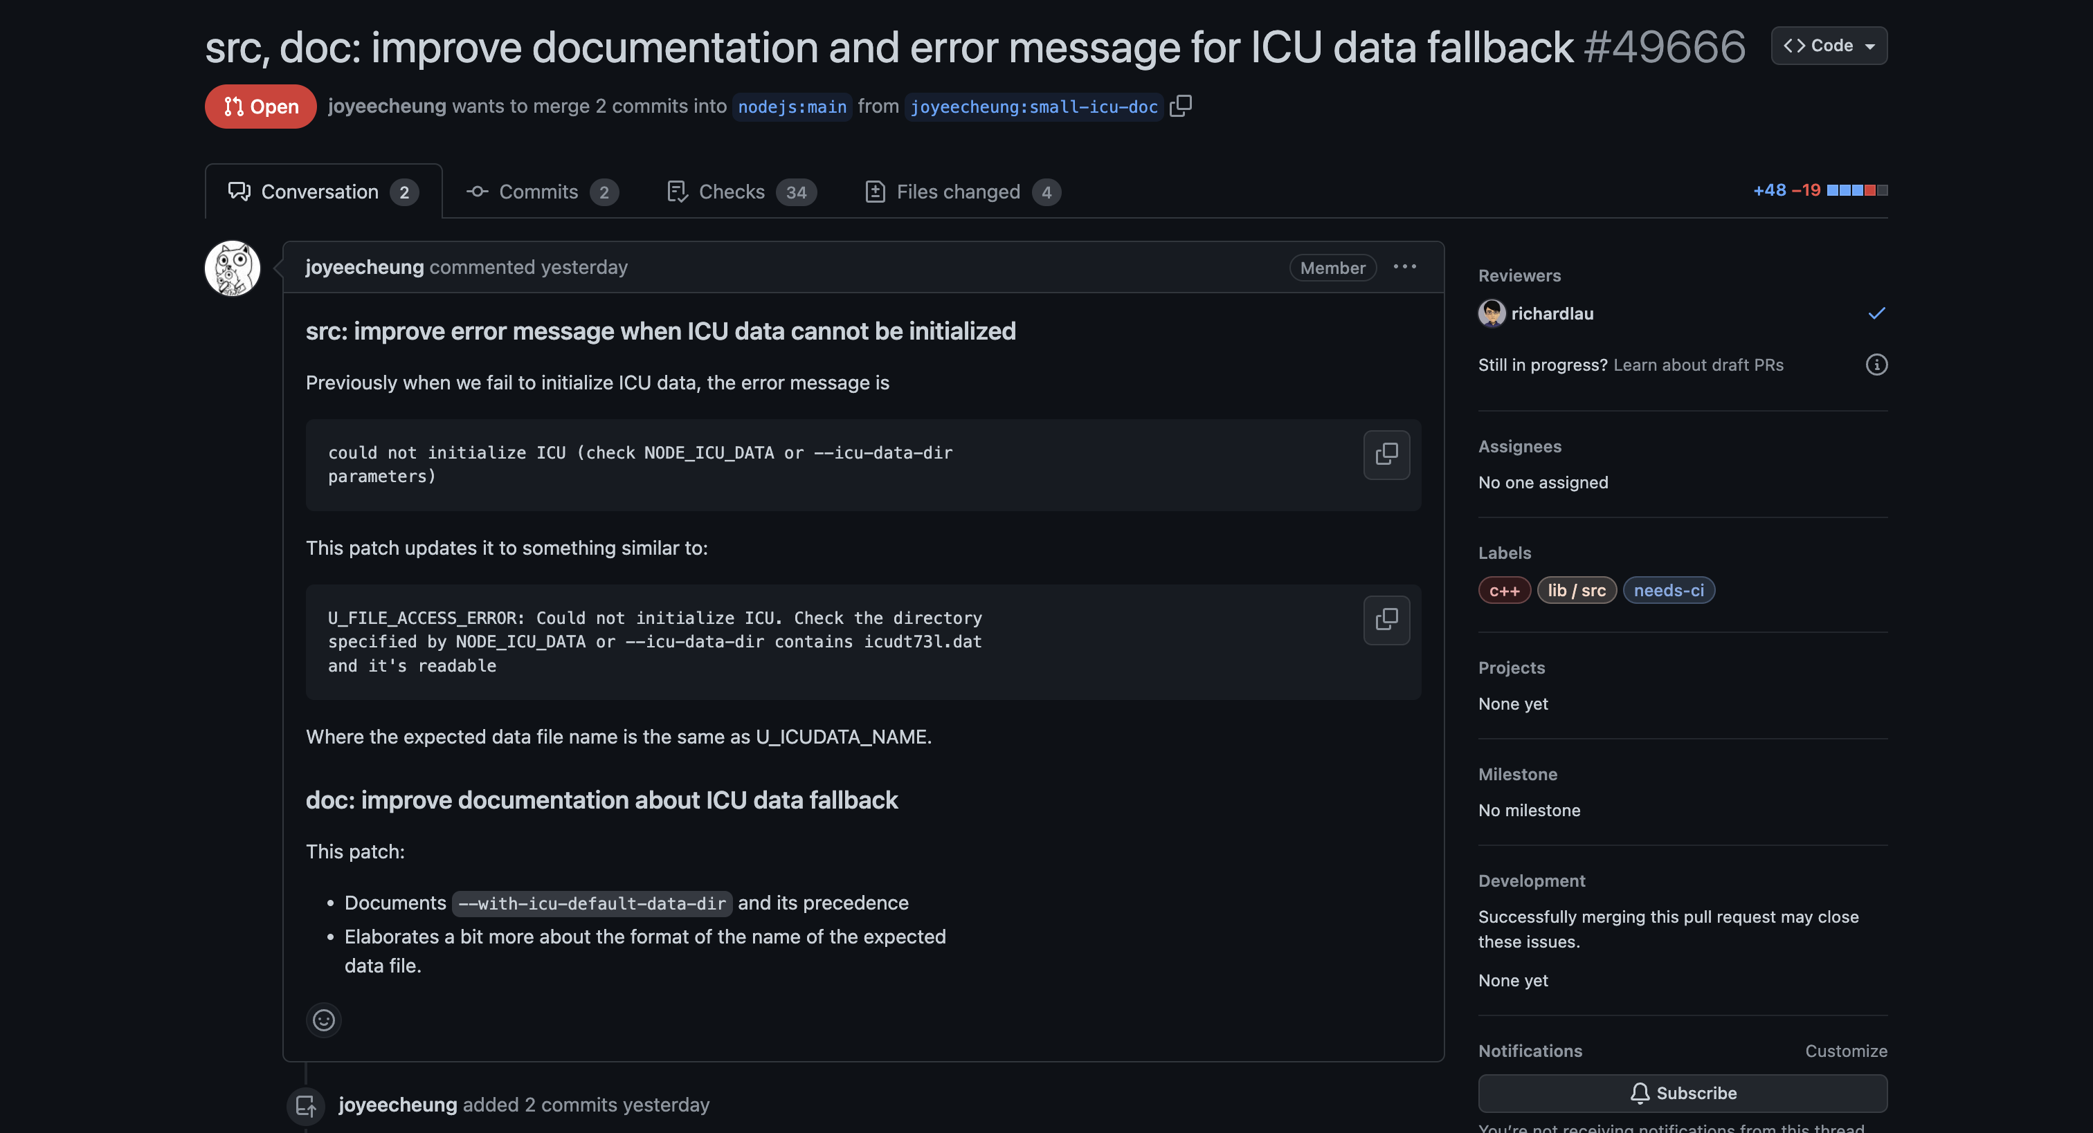

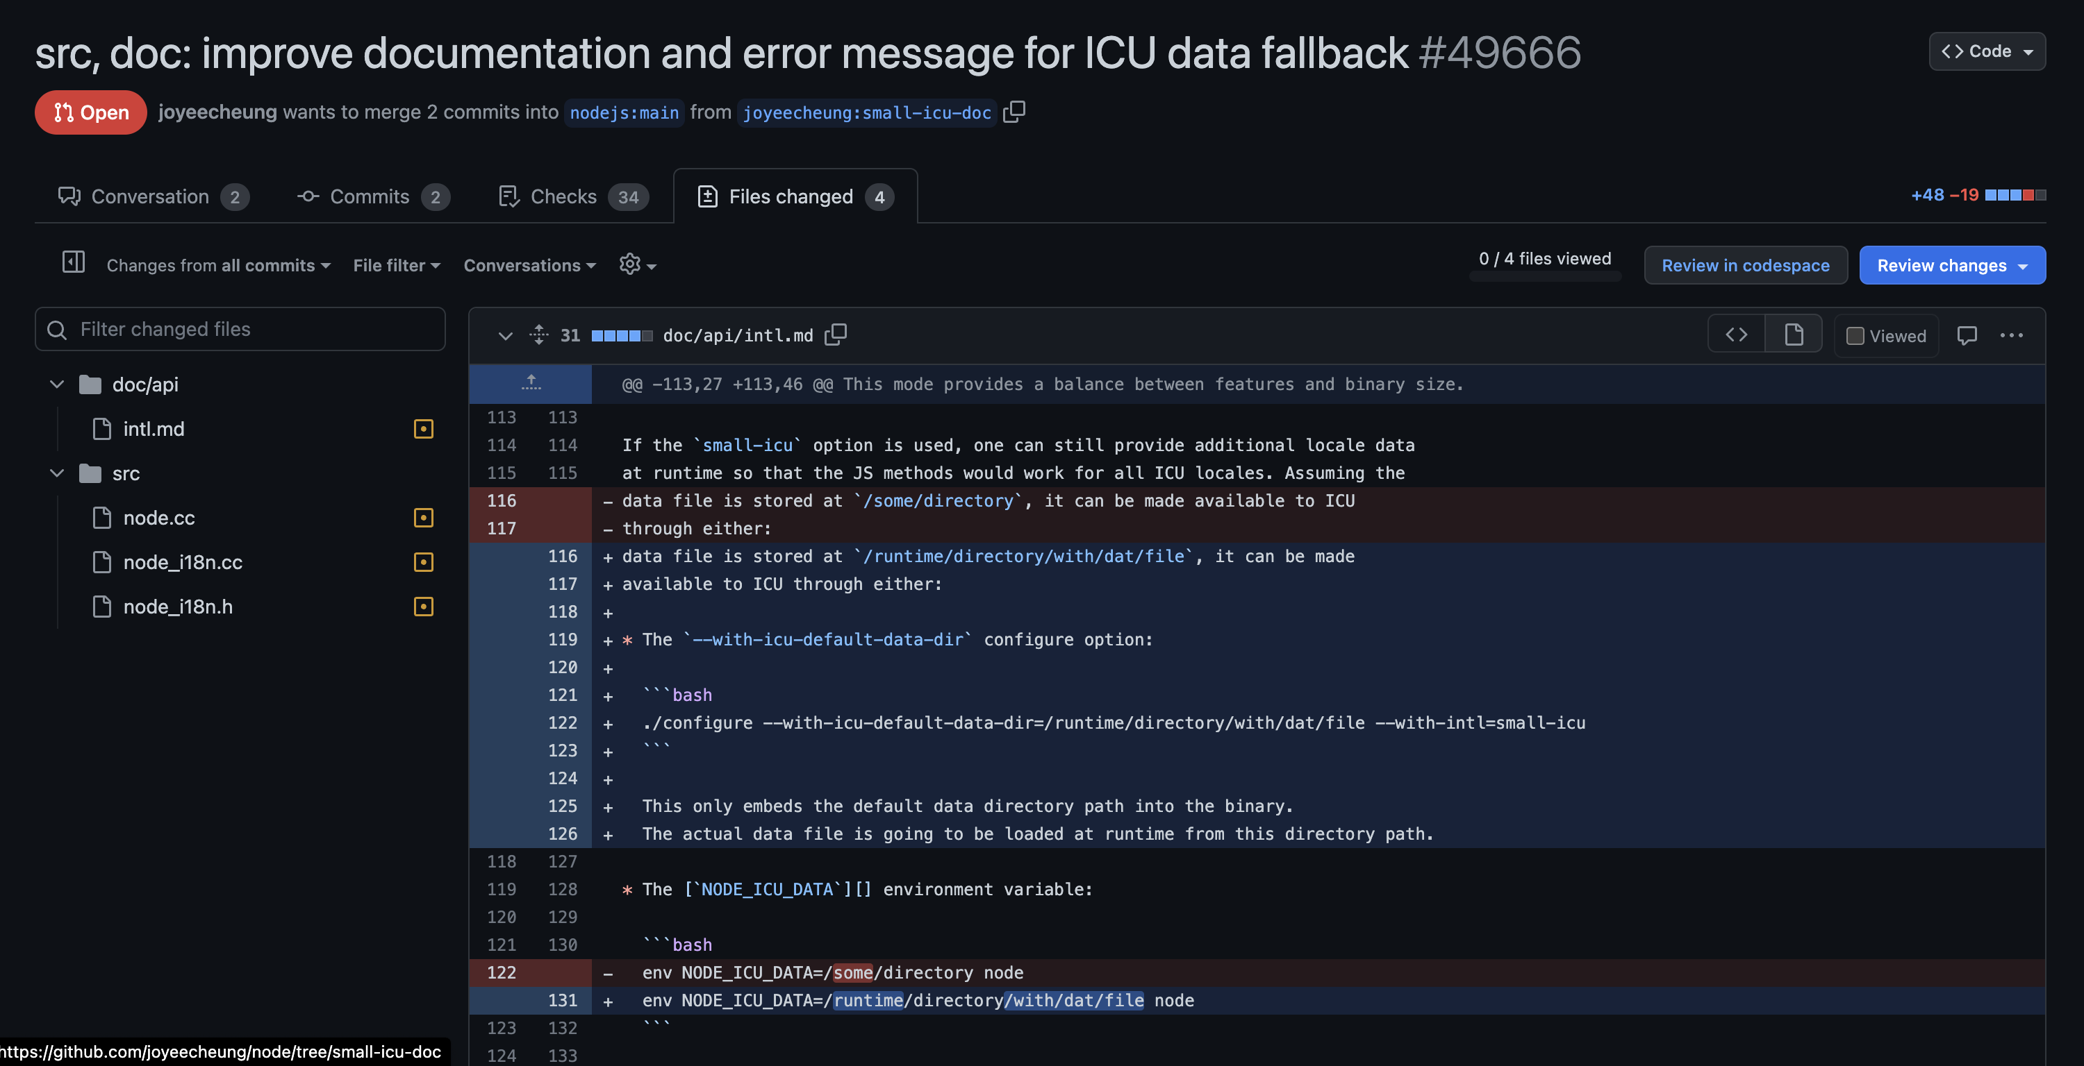

4. 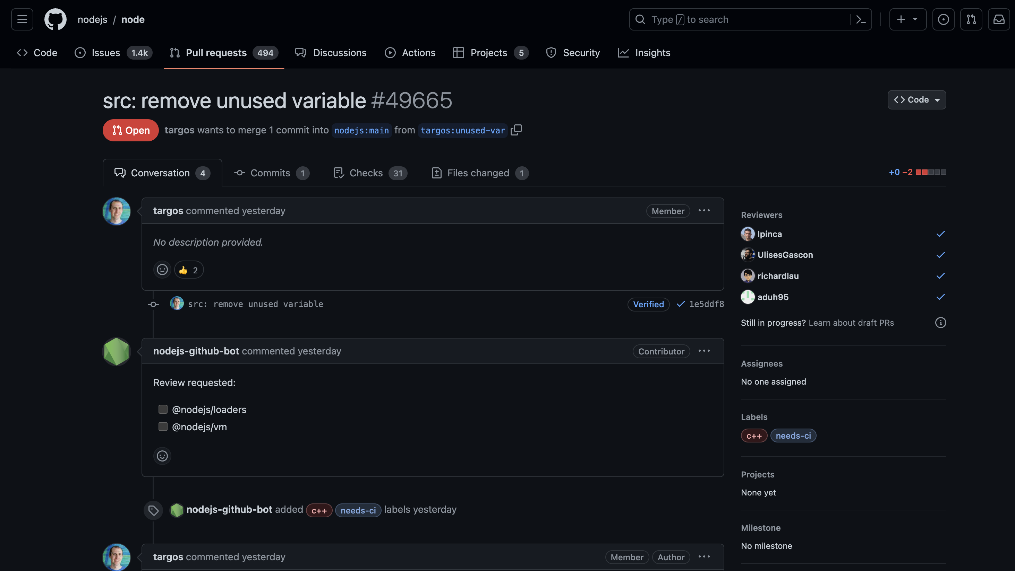

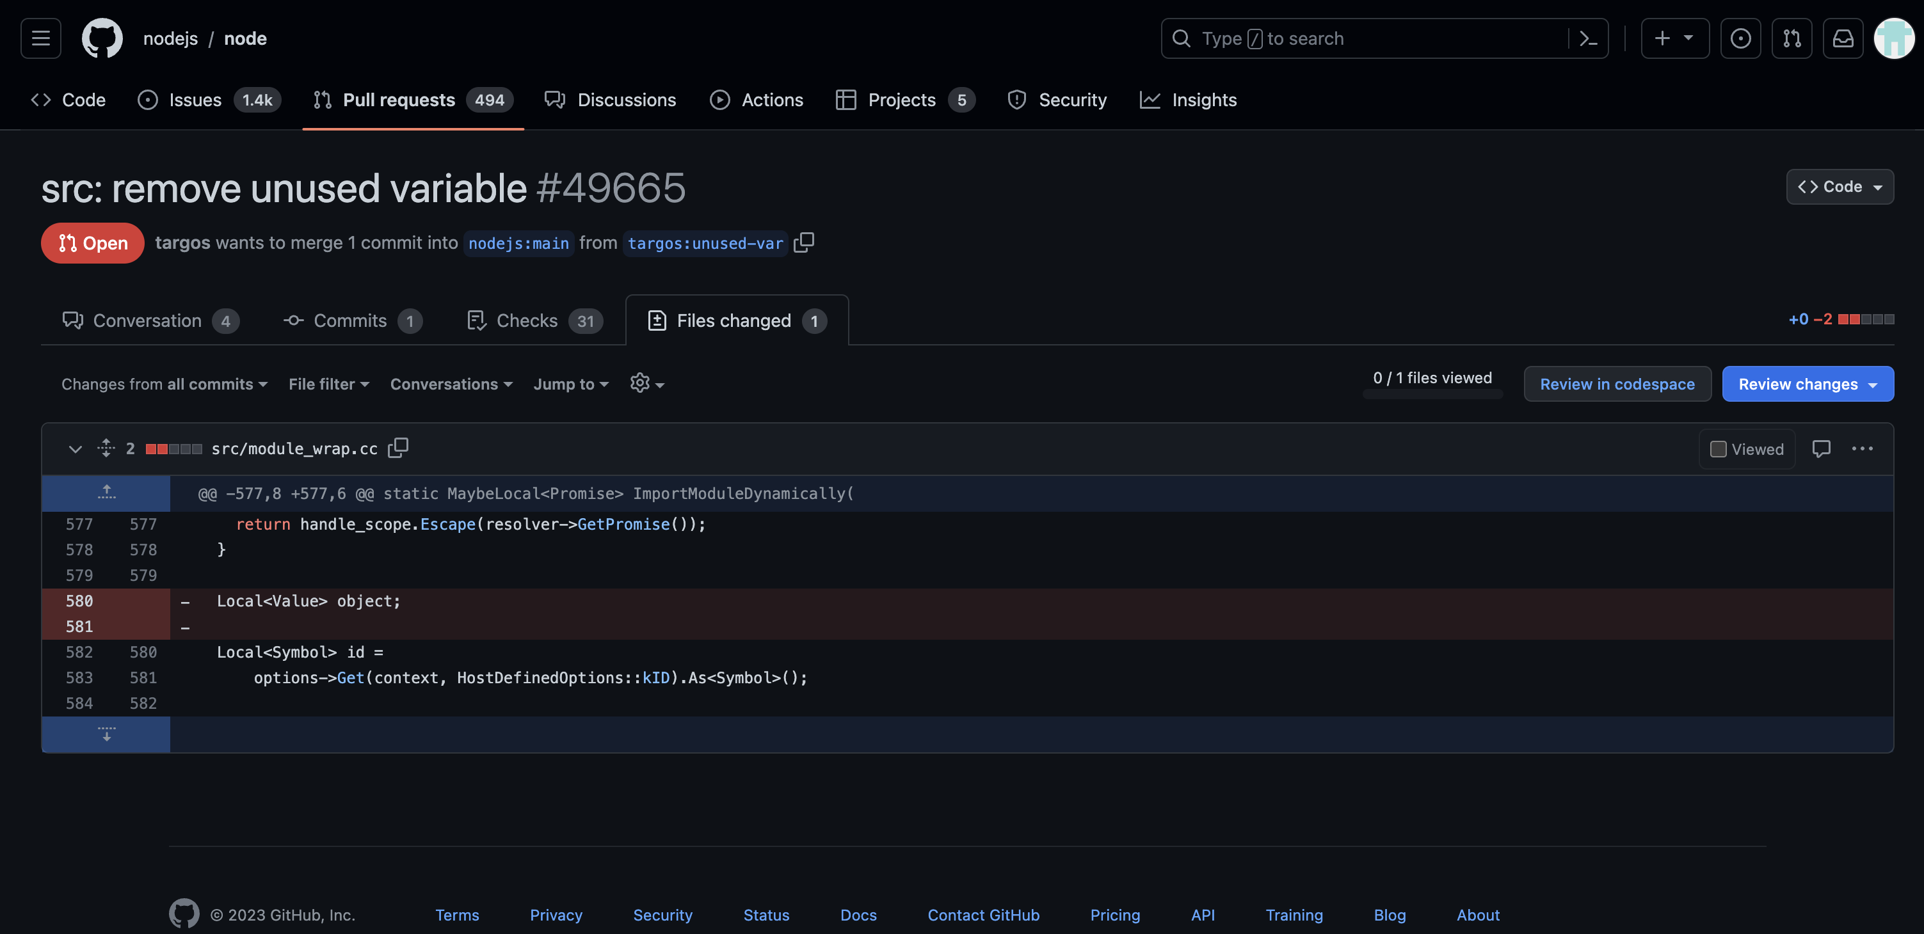

5. 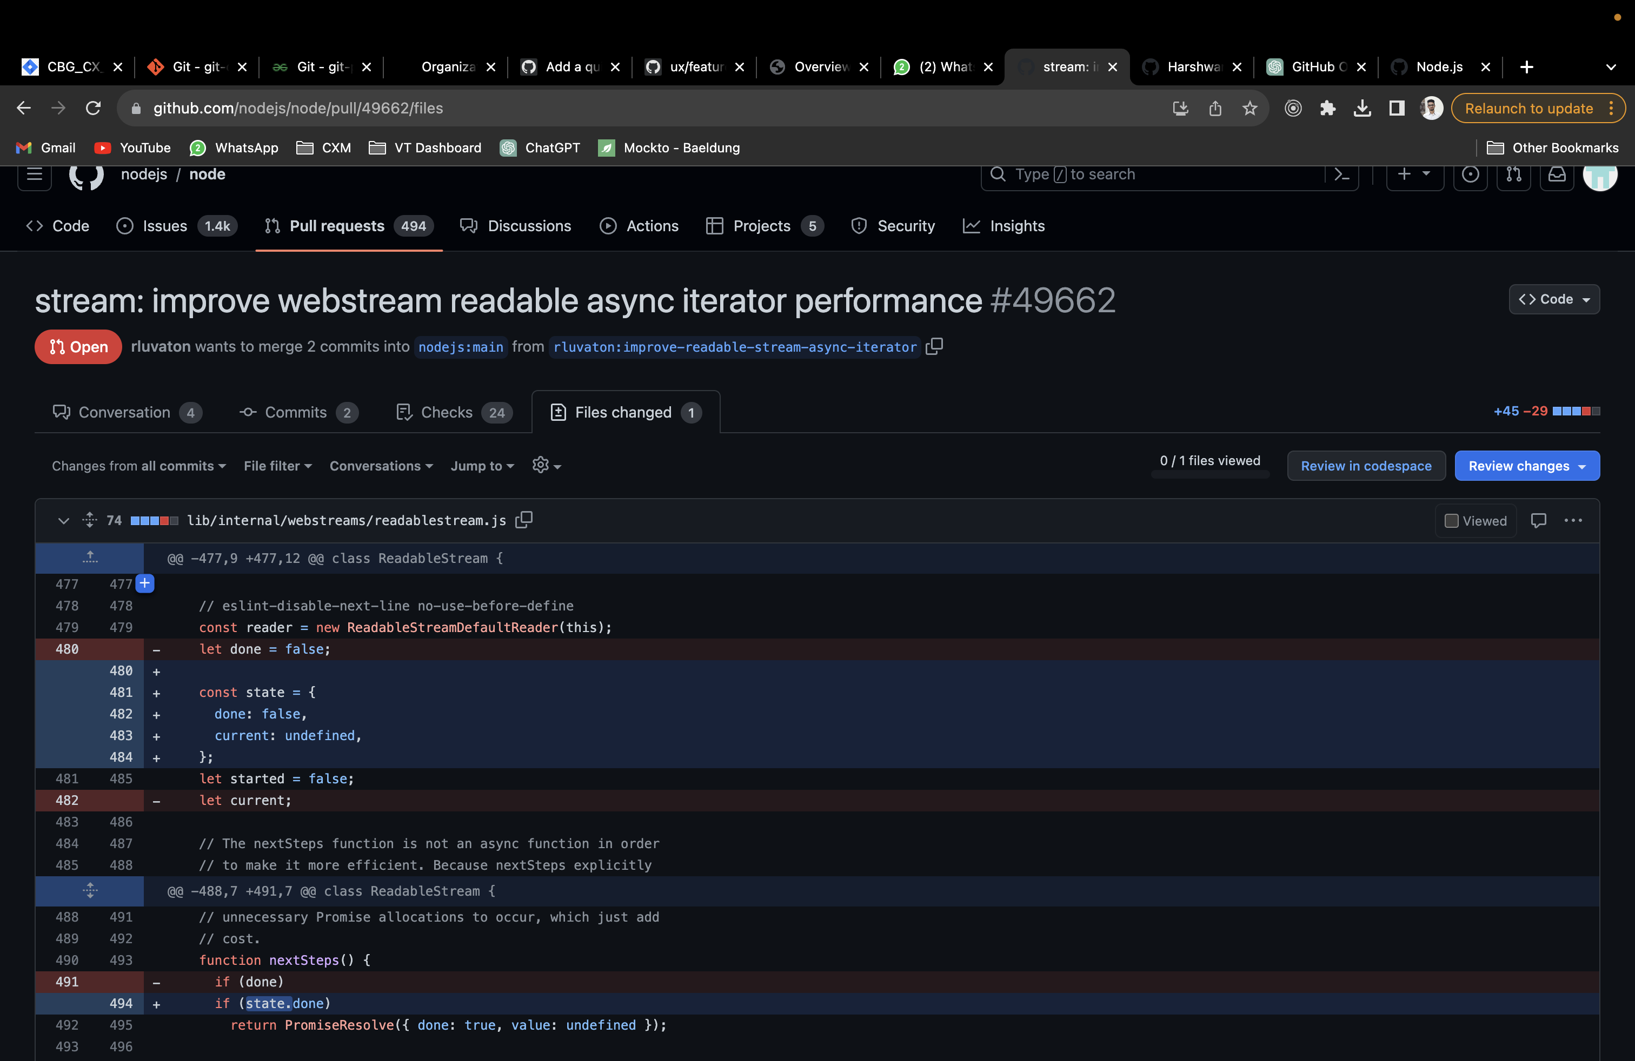

List the most recent 5 Closed Pull Requests:

* <<Closed pull request 1, with snapshot of files modified, comments by contributor and admin, along with your observations>>

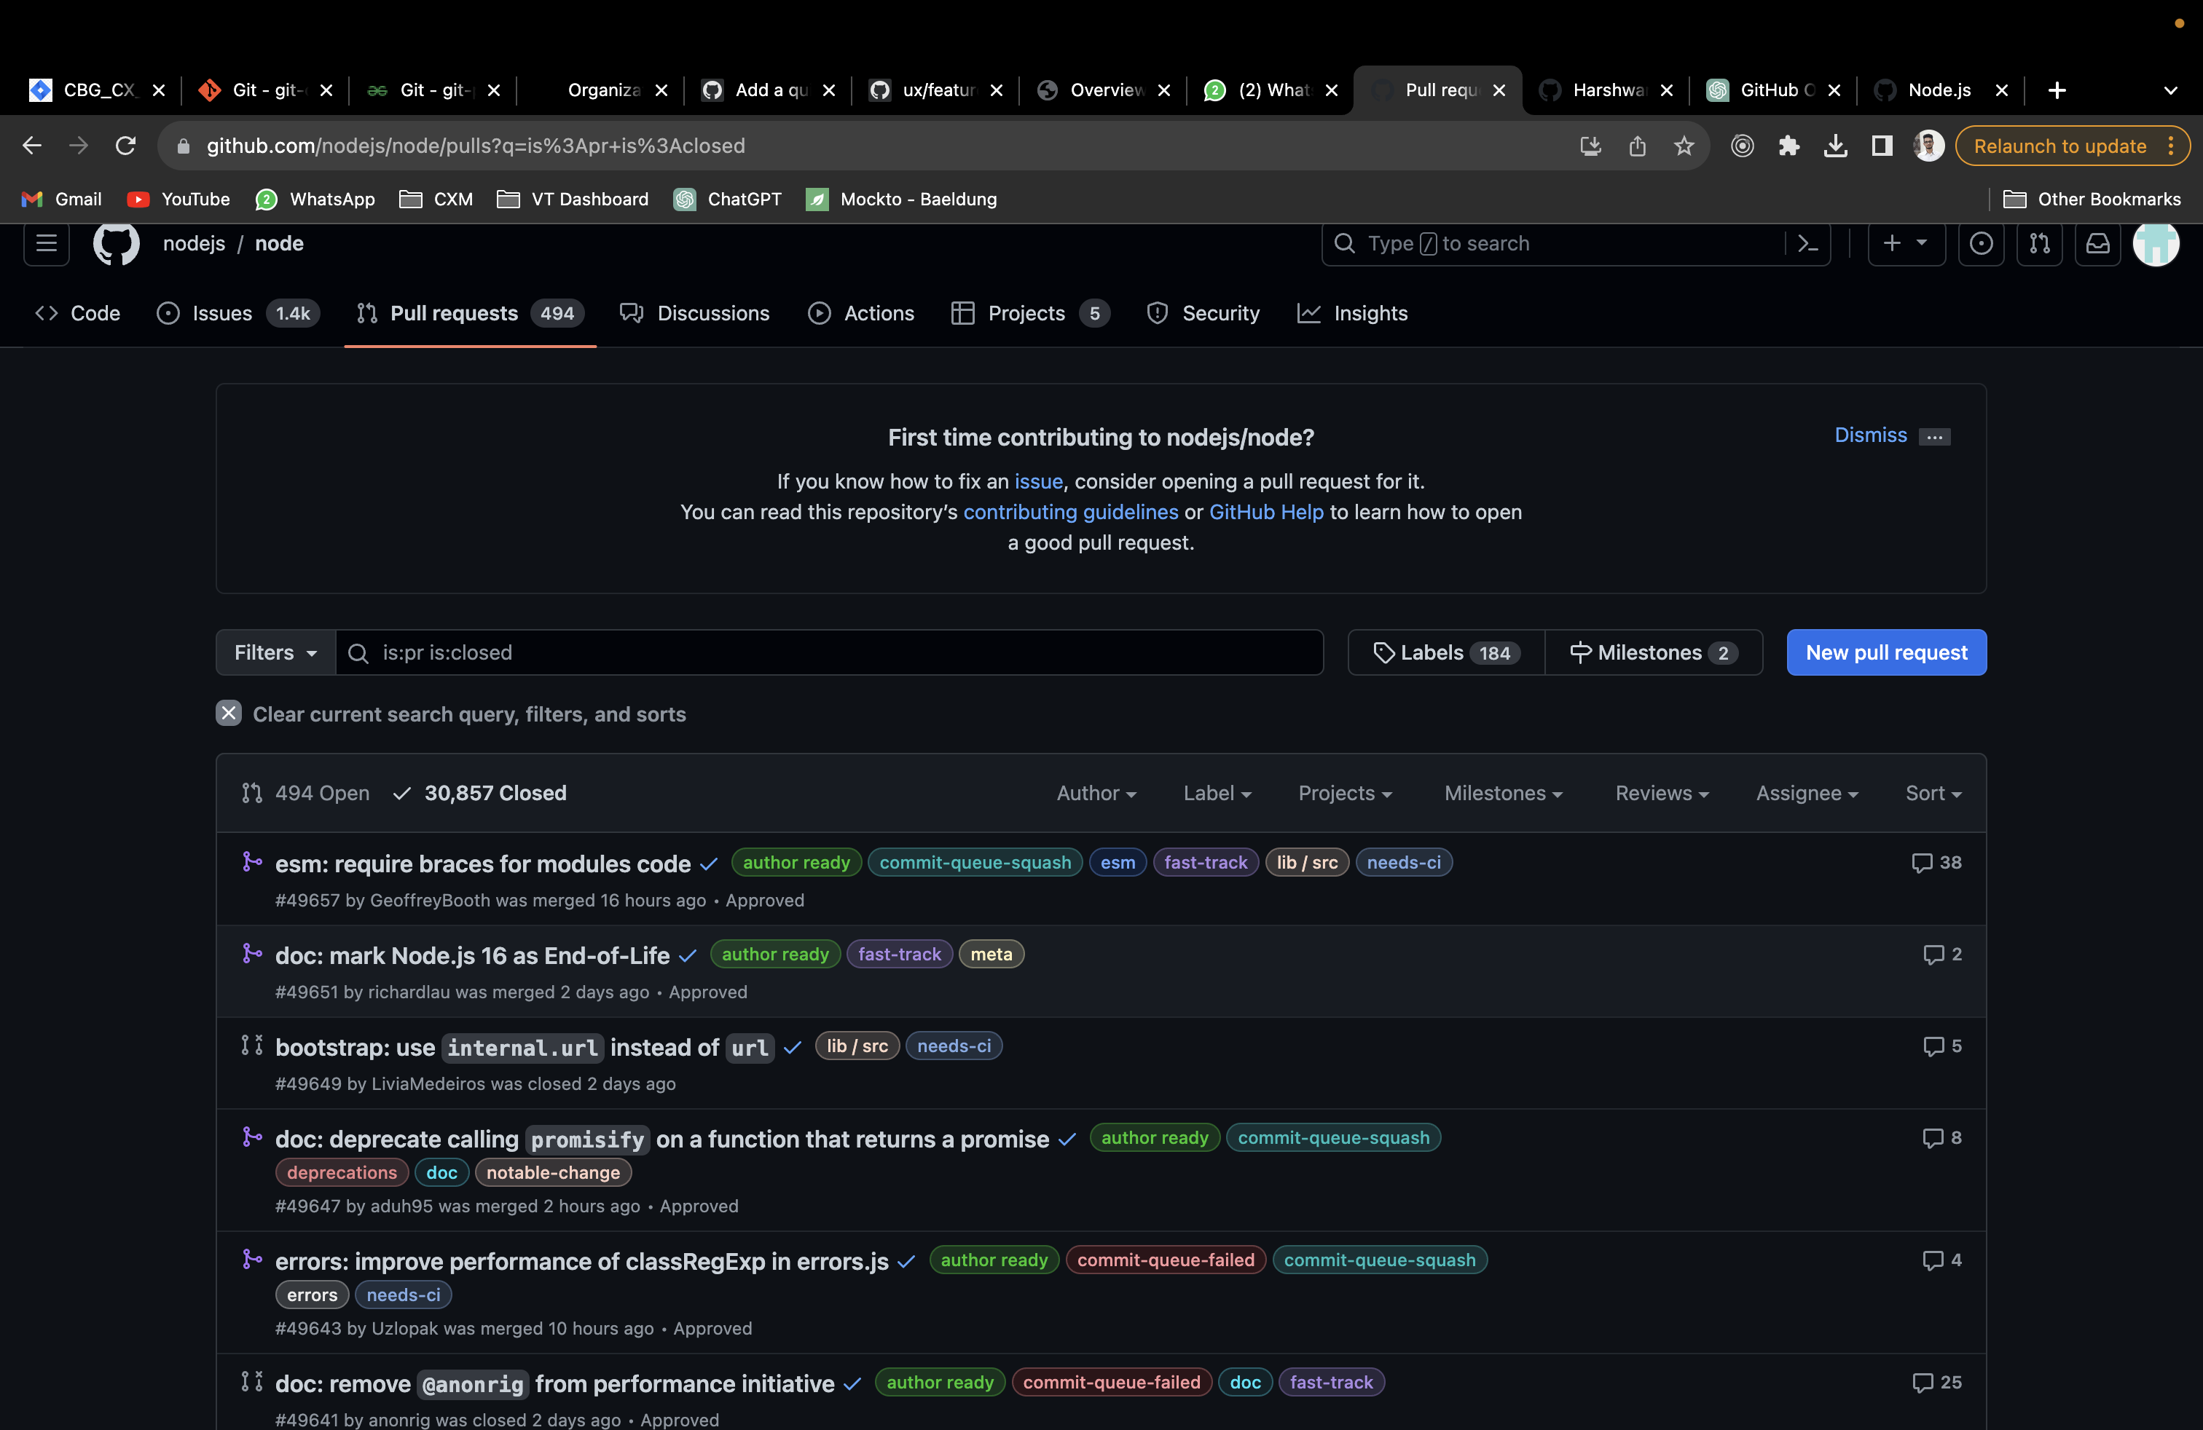

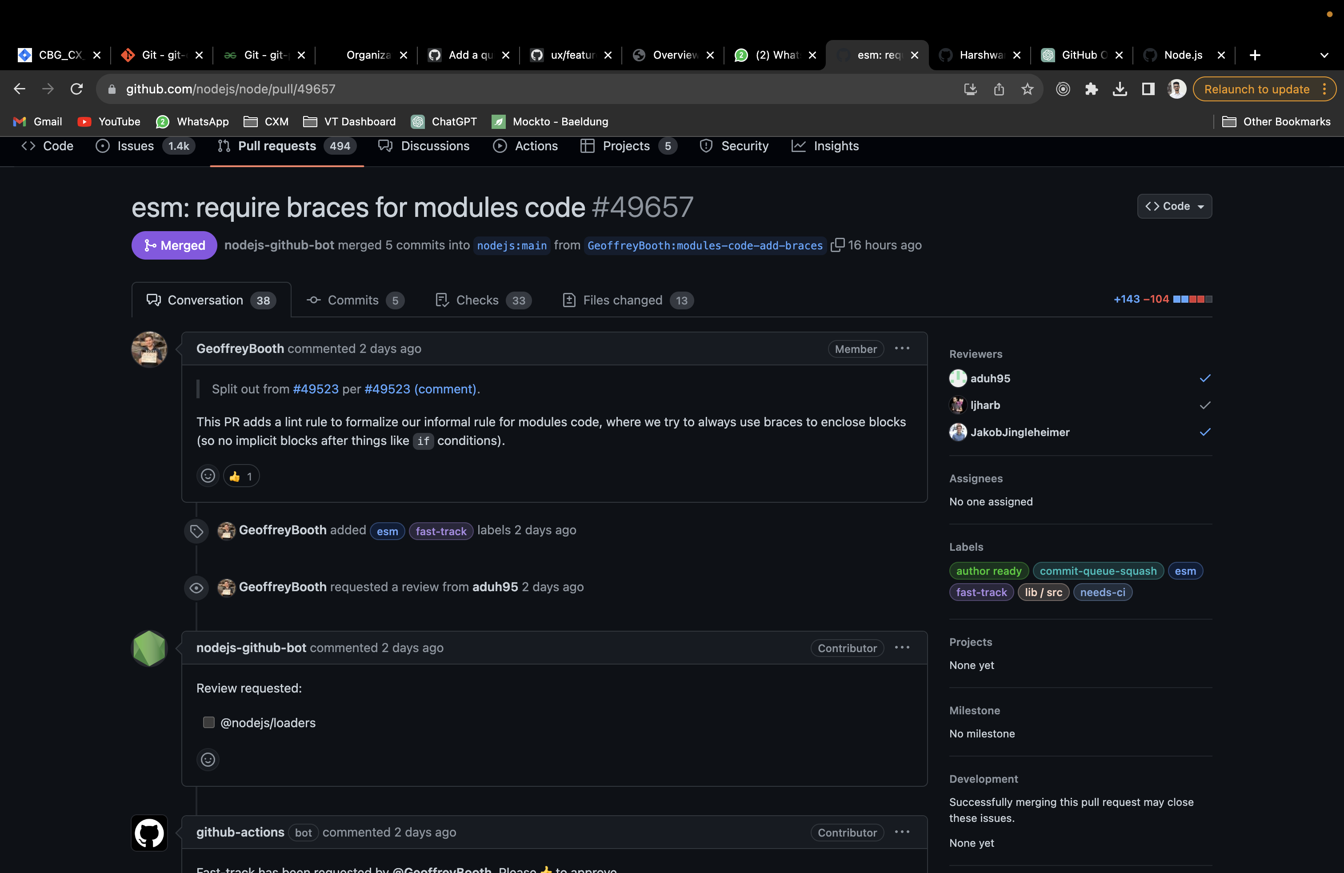

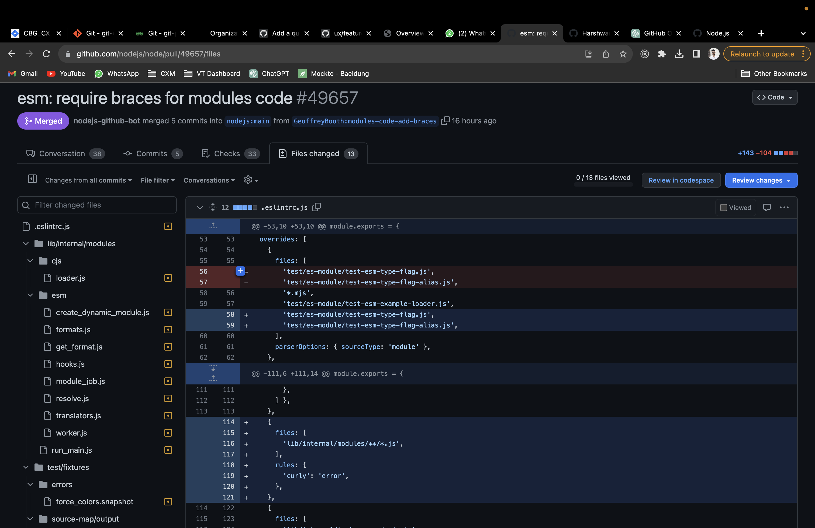

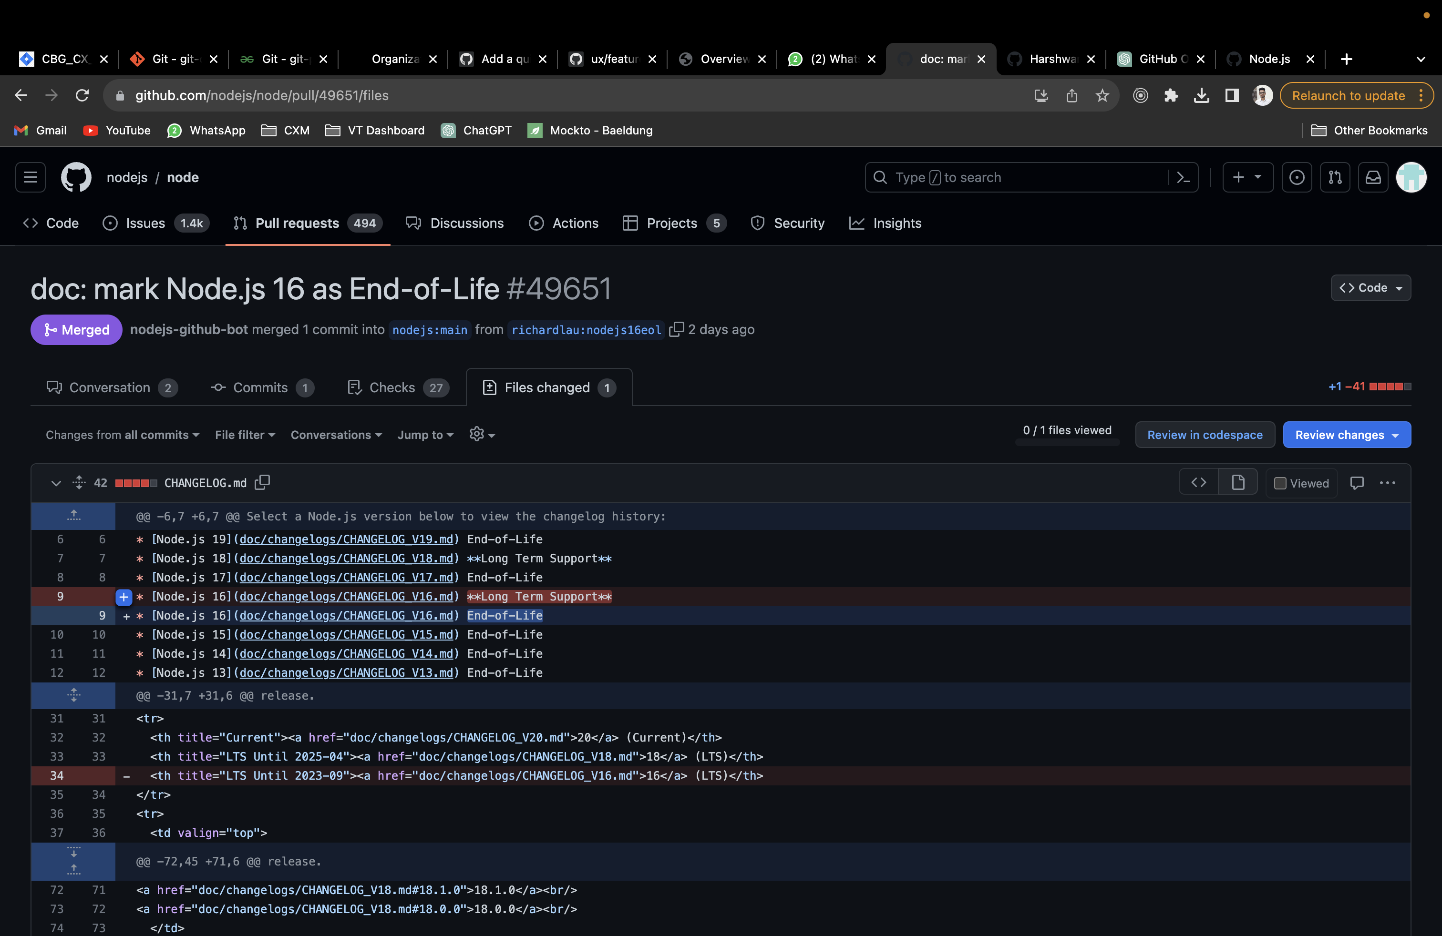

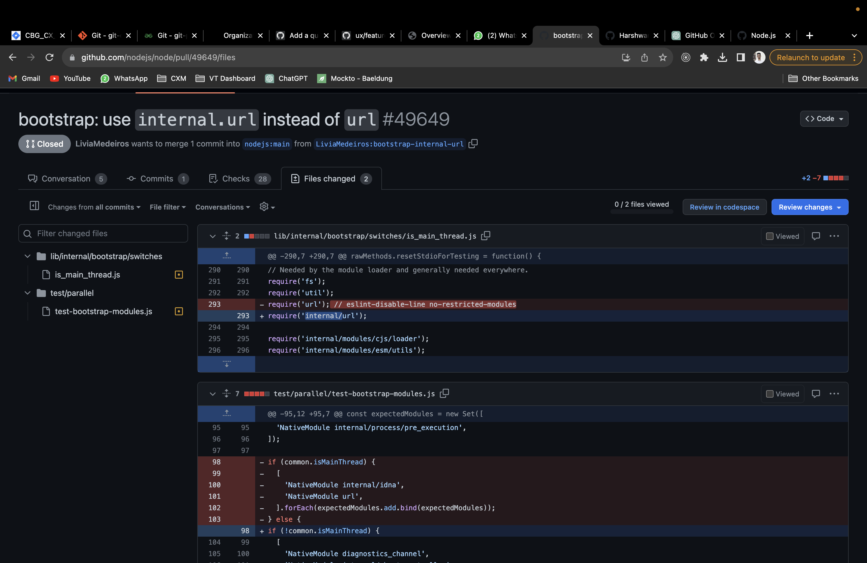

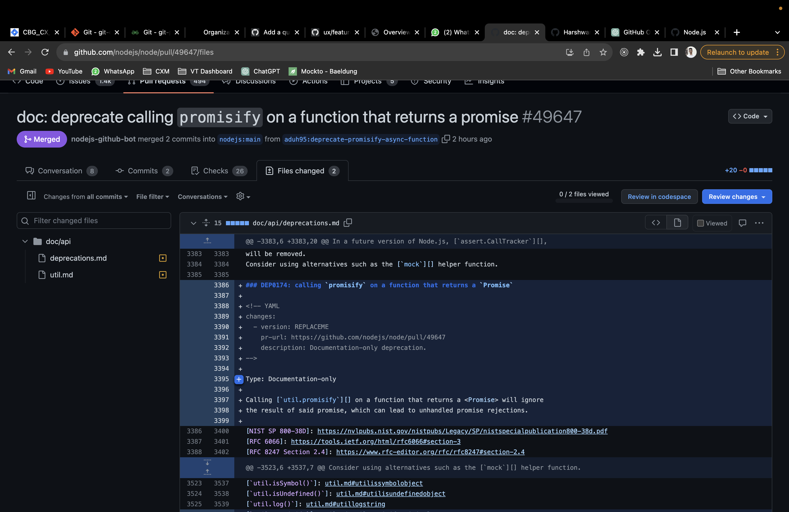

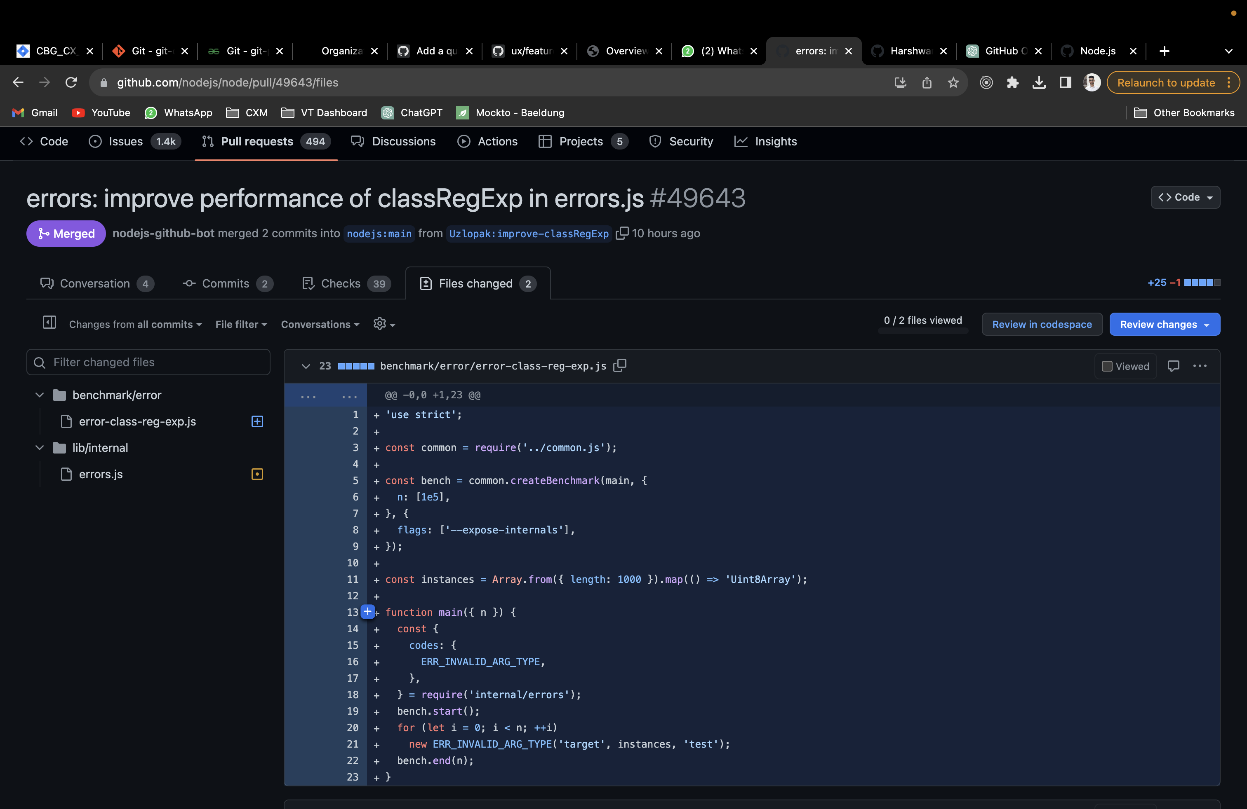

Number of forks of the repo:

26.8K

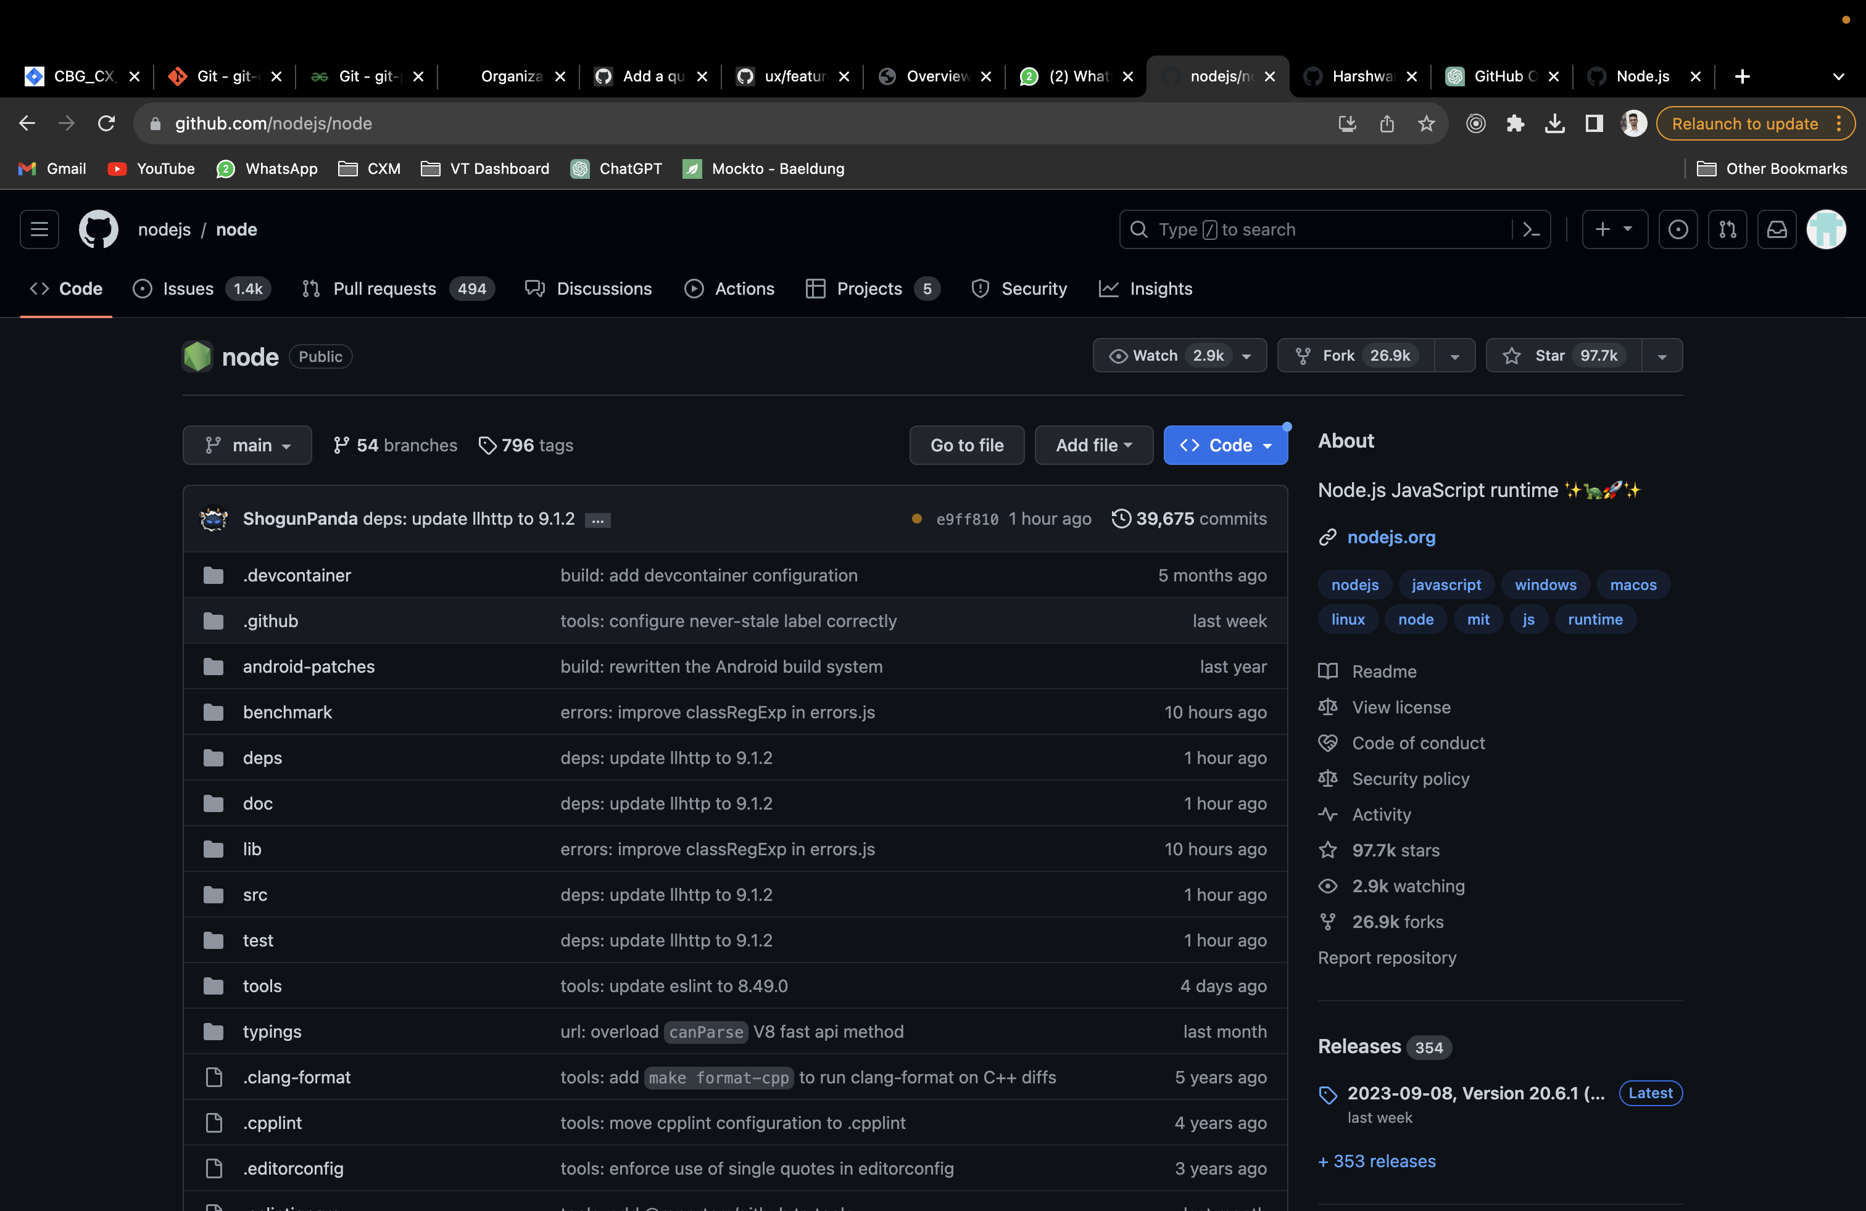

**Project 2 (https://github.com/angular/angular):**

**Project Details:**

Angular is a popular open-source web application framework primarily maintained by Google and a community of individual developers and corporations. It's designed to help developers build dynamic, single-page web applications (SPAs) and provides a comprehensive set of tools and libraries for creating complex, client-side applications.

Total number of contributors:

List of top 5 contributors:

* <<contributor 1, with images of top 5 open and closed pull requests by them, with observations>>

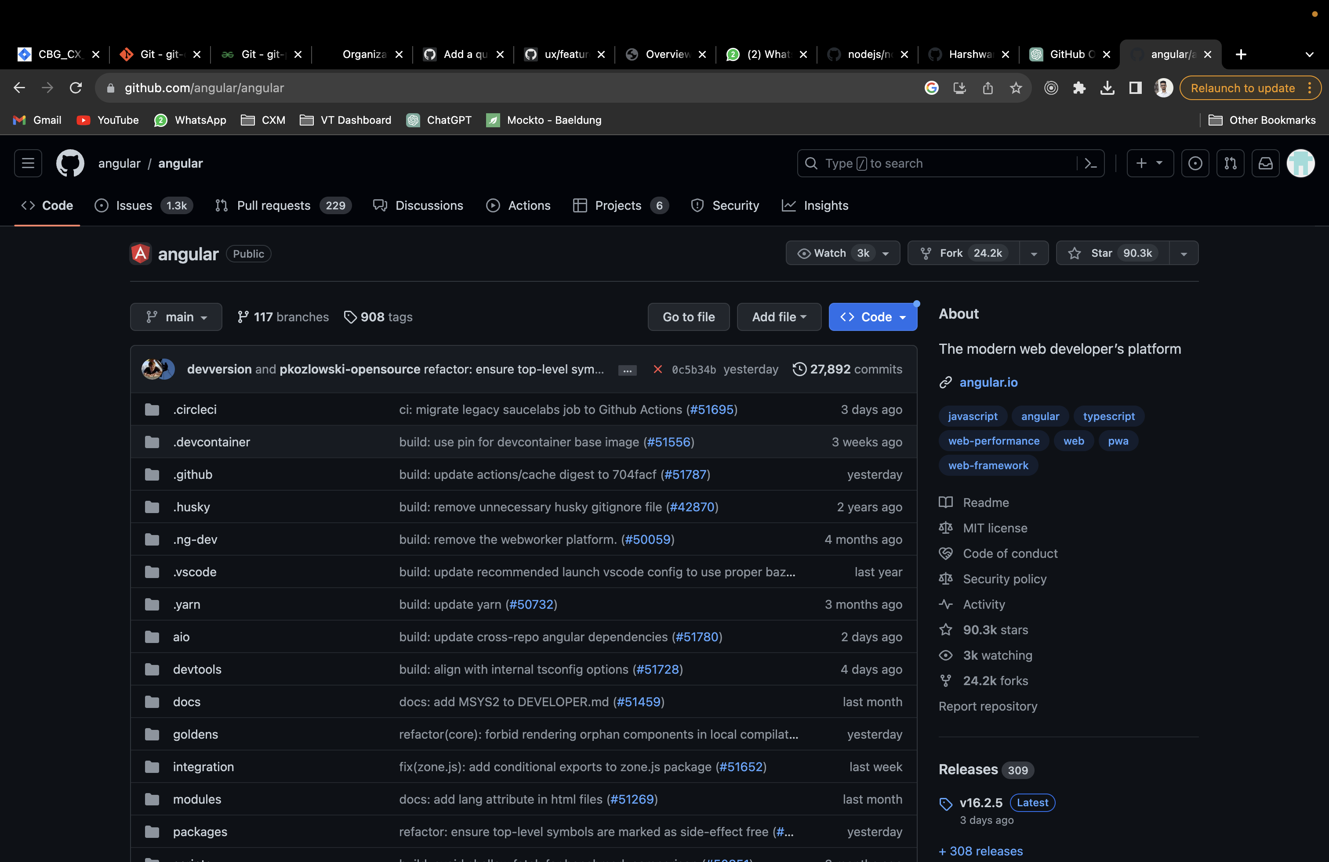

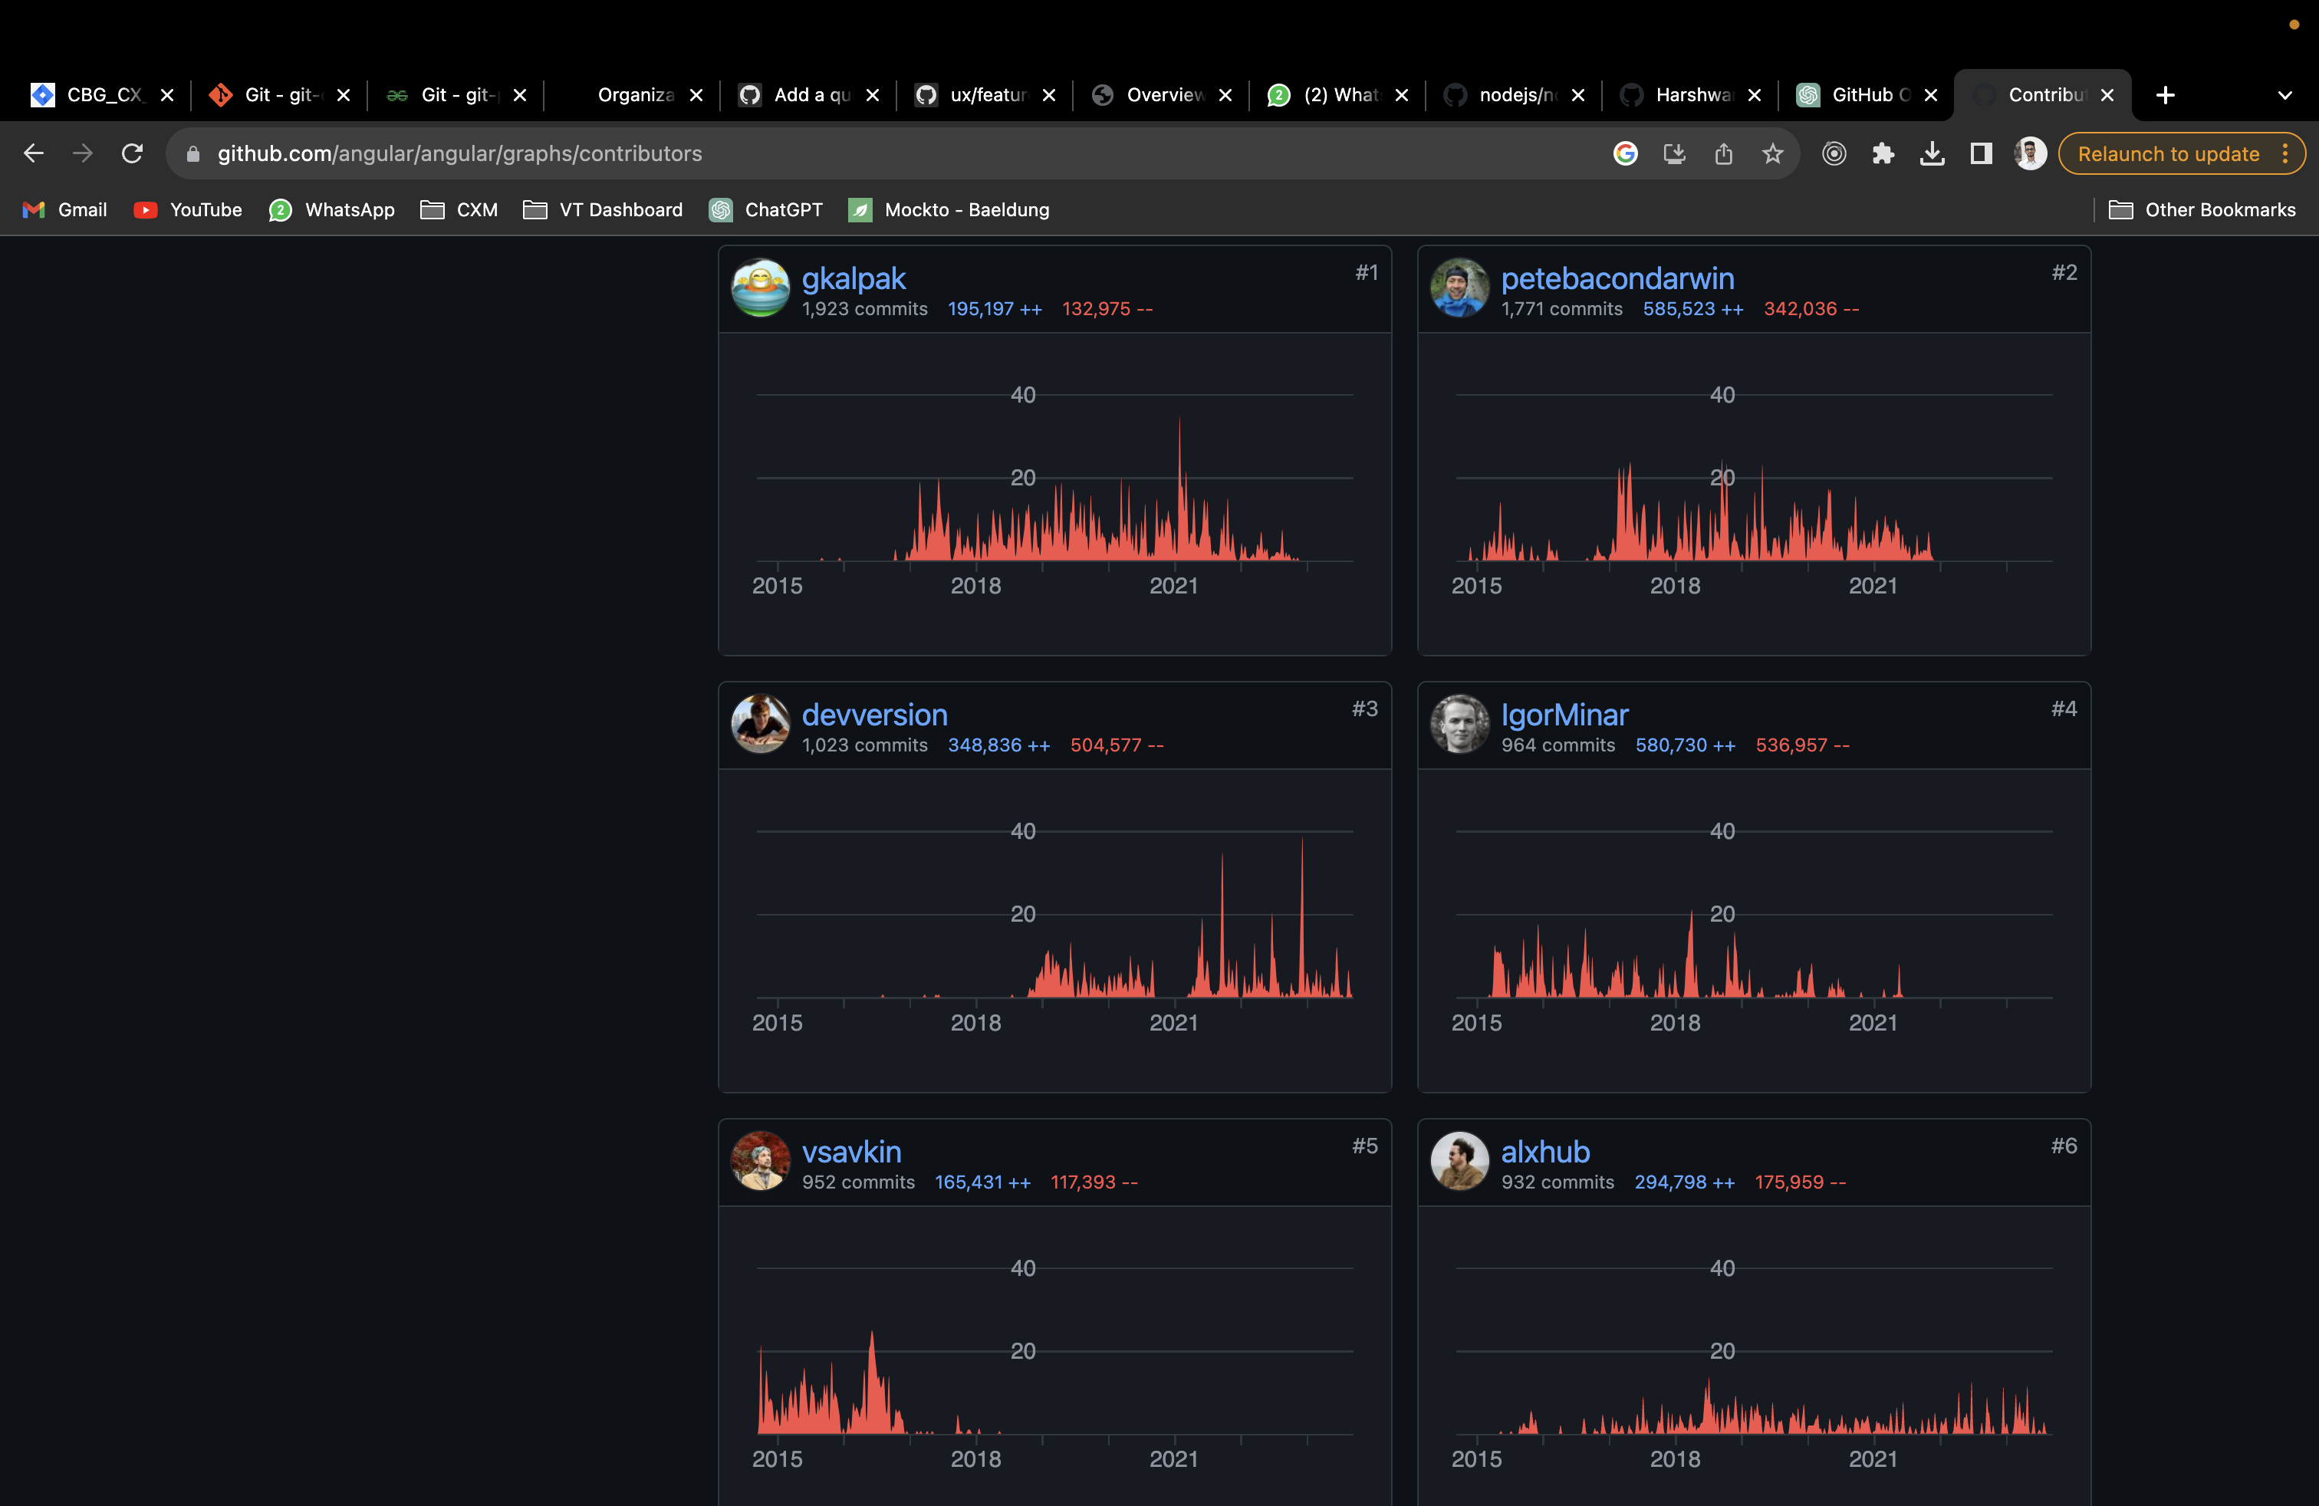

1. 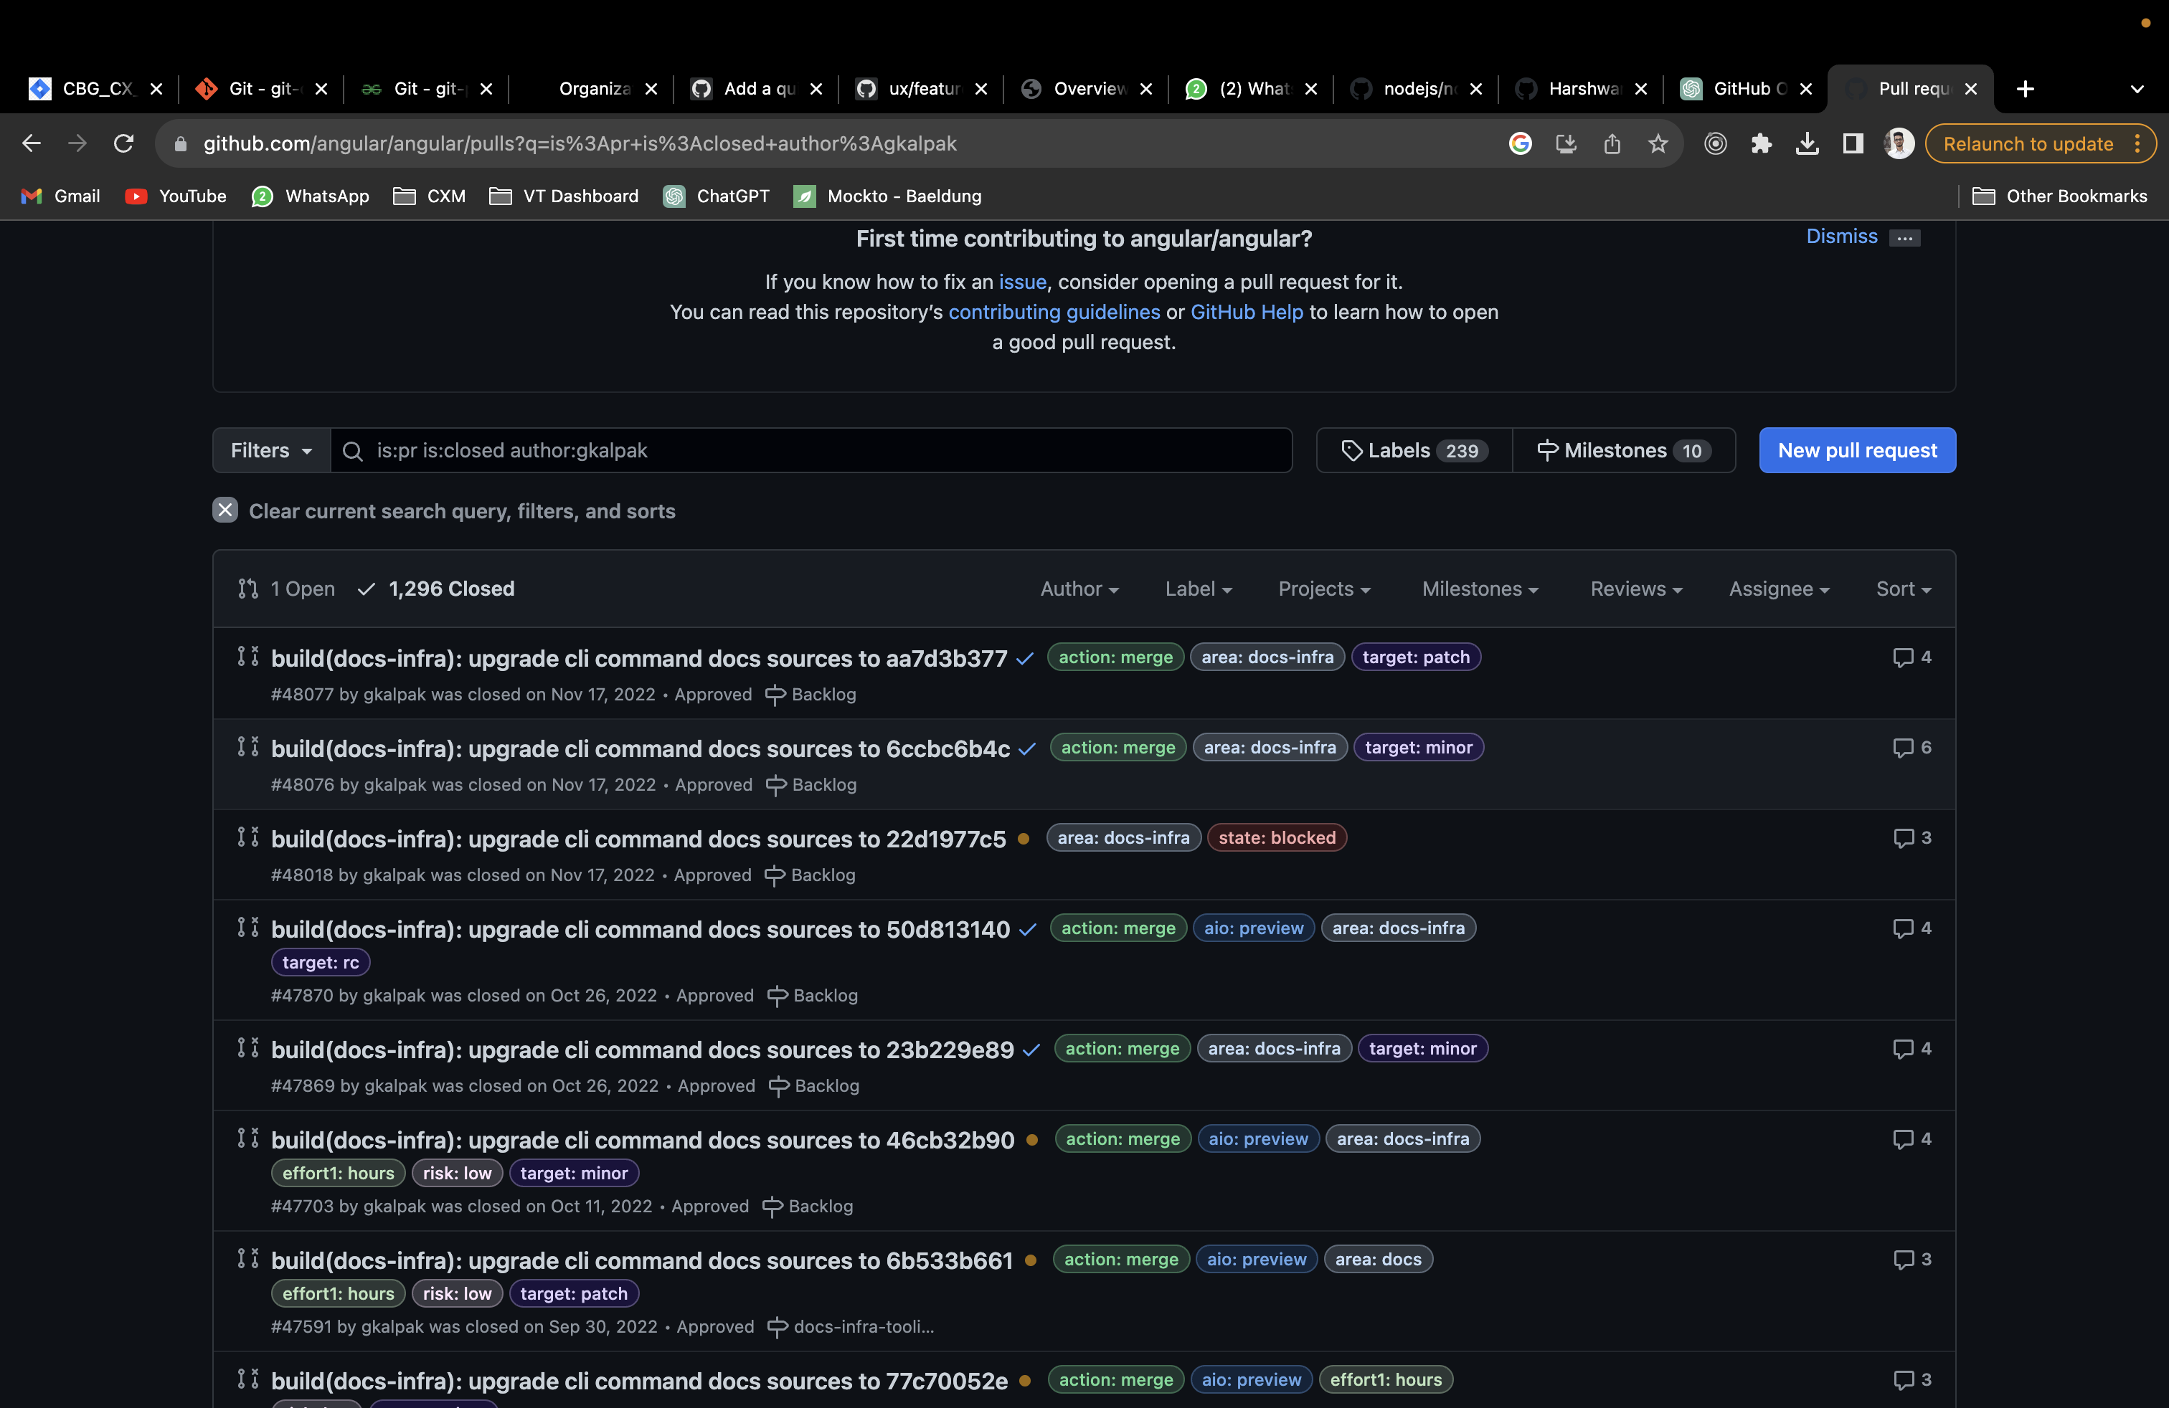

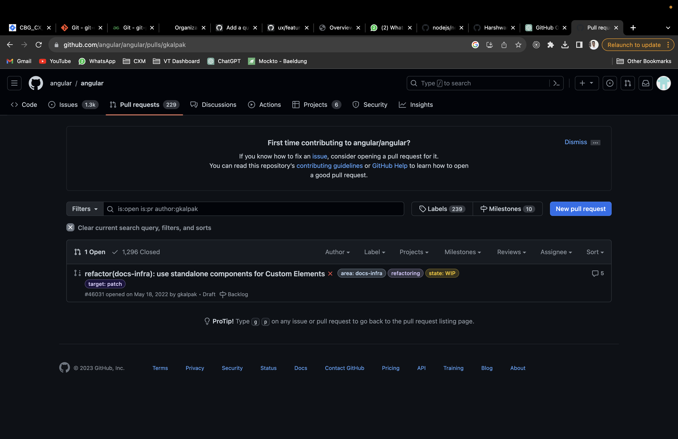

1. 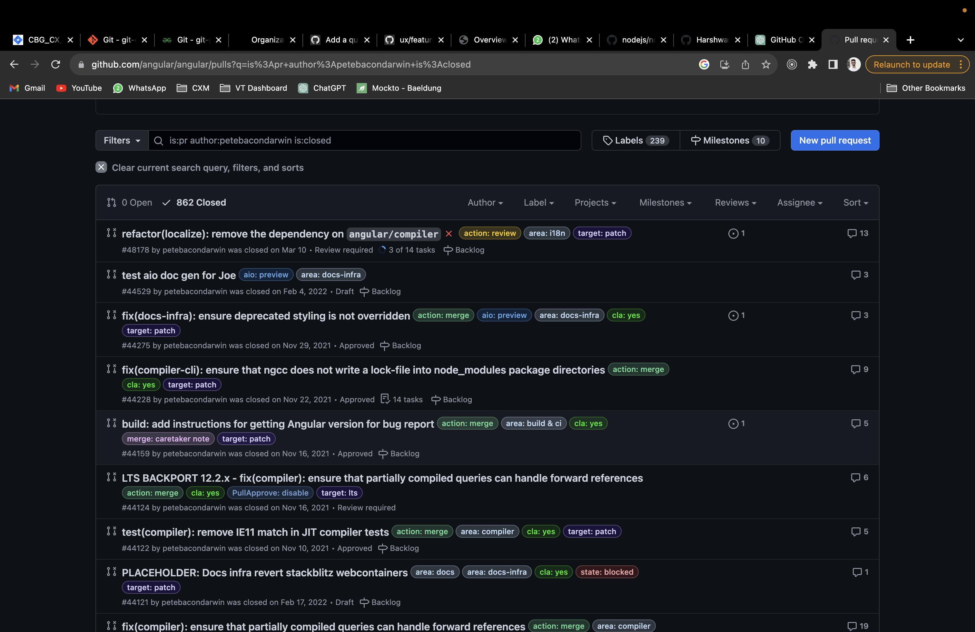

3.

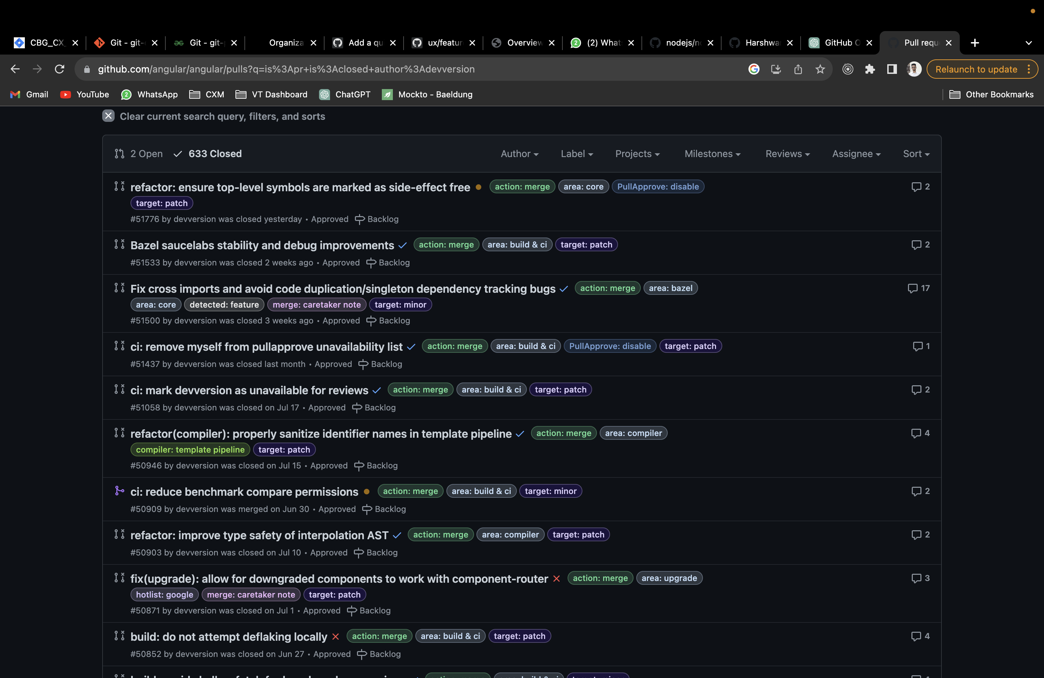

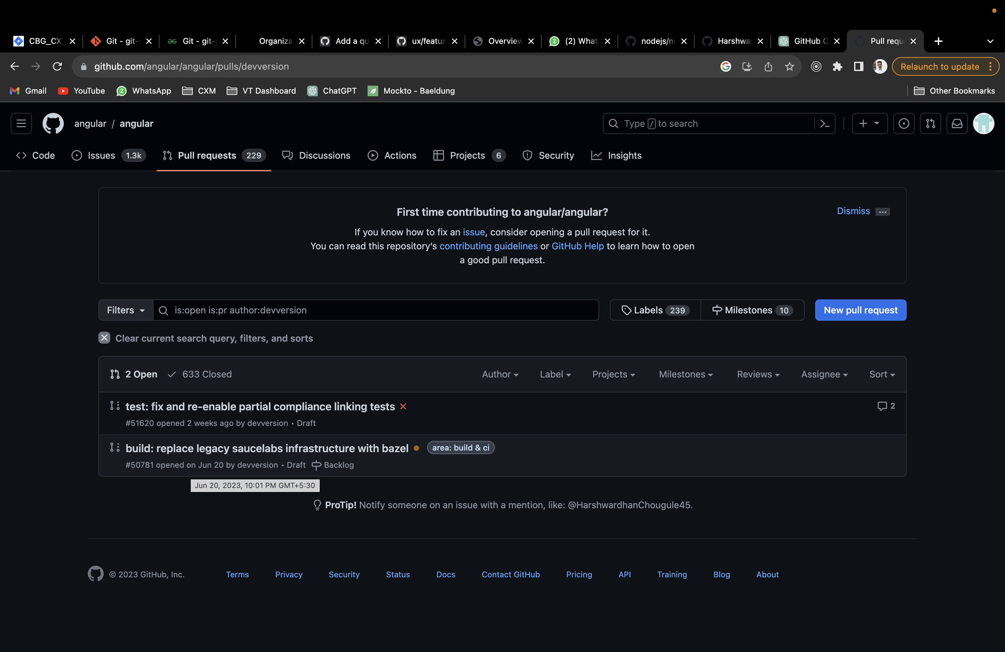

Details of pull requests (open and closed):

Open:-

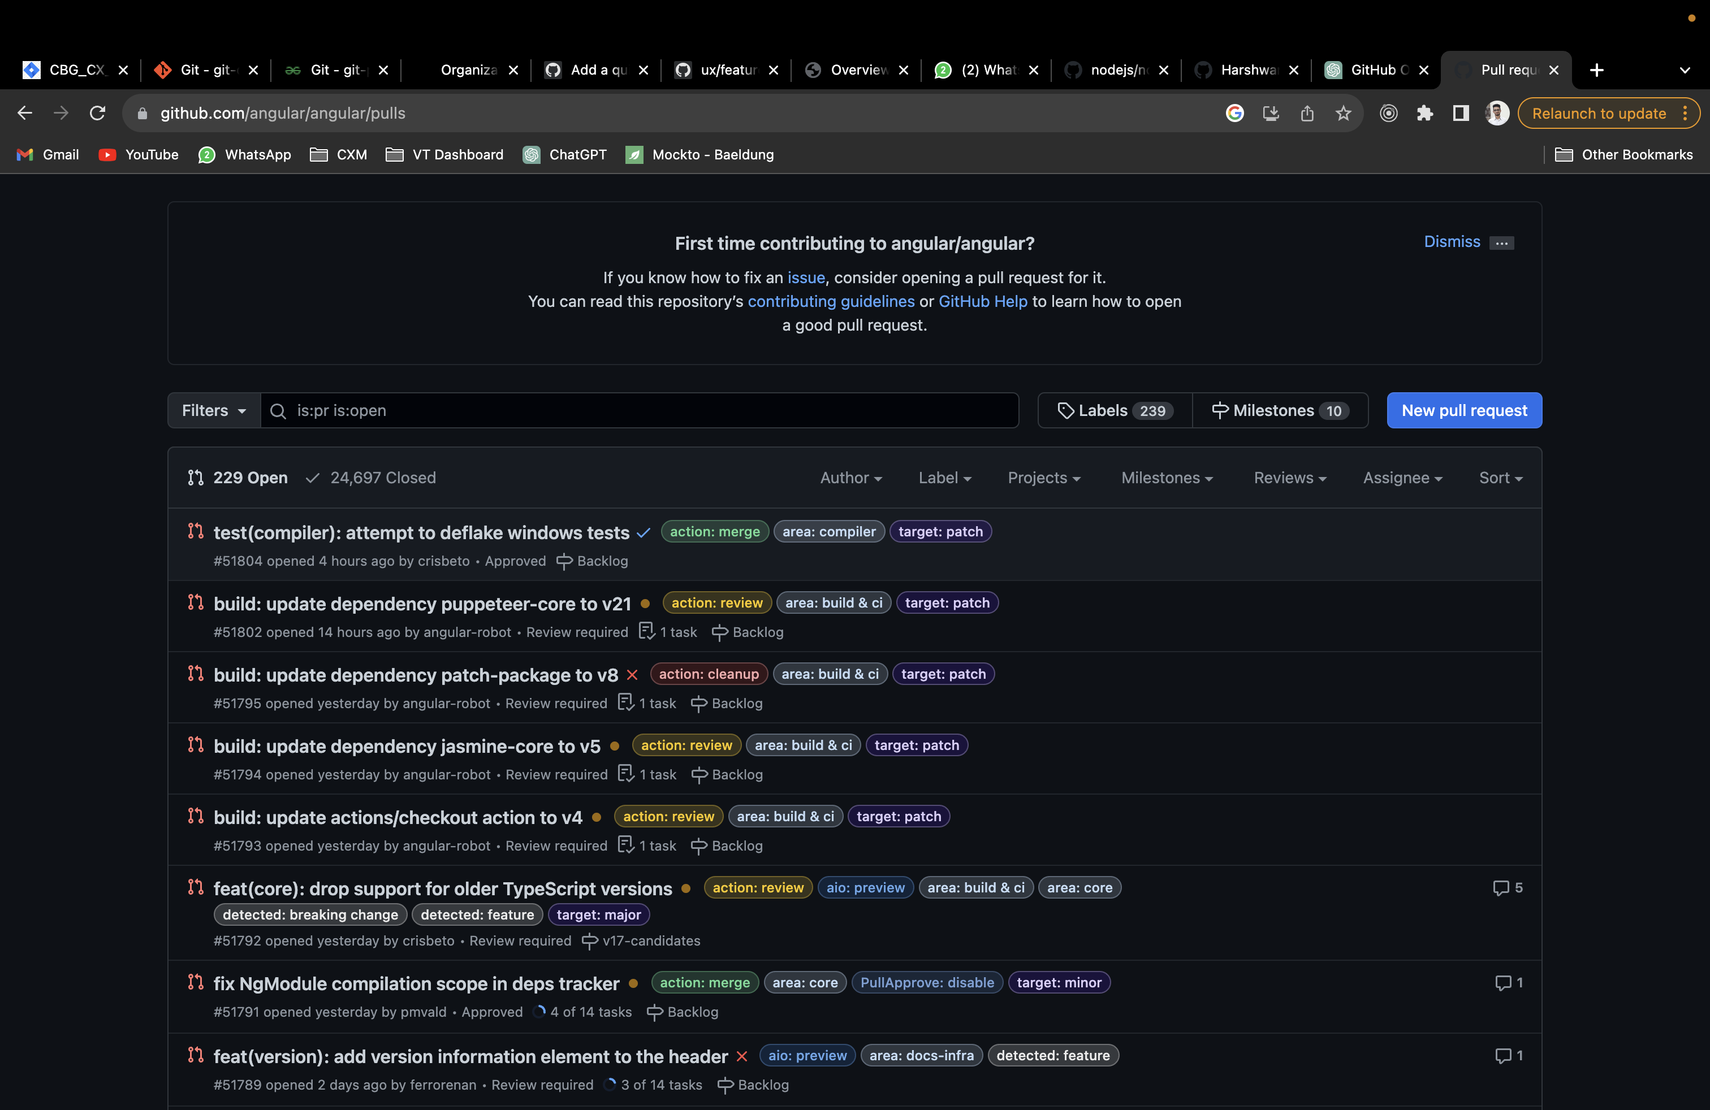

1.

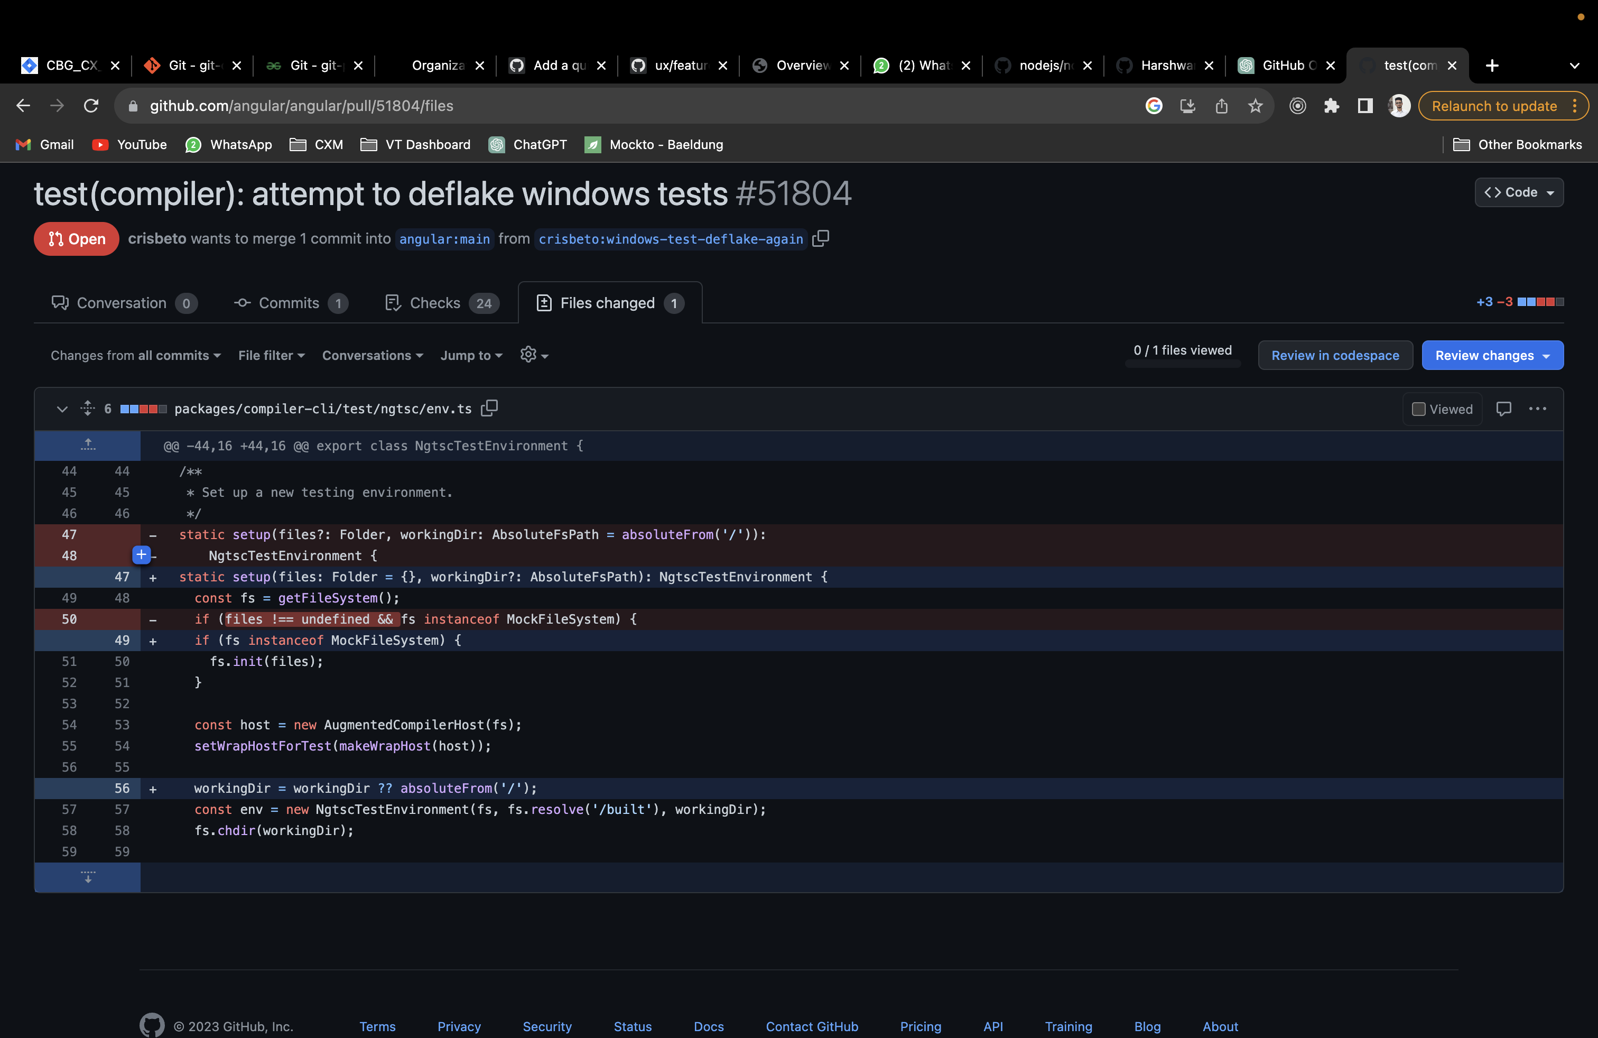

2.

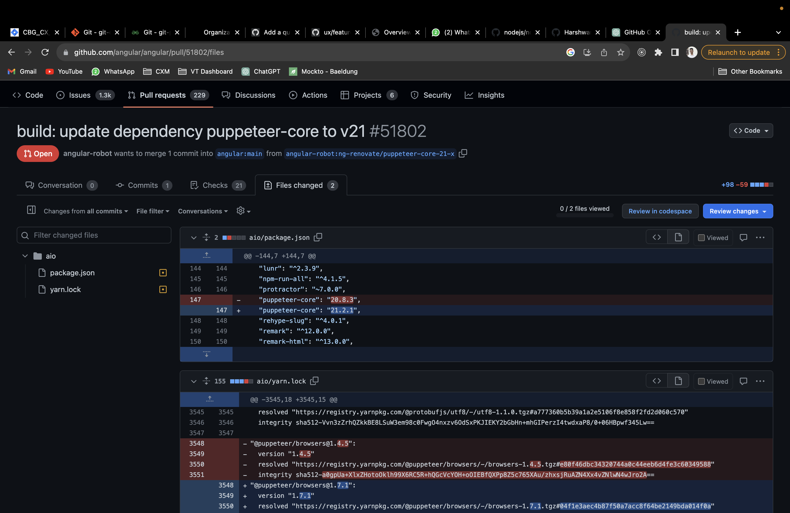

3. 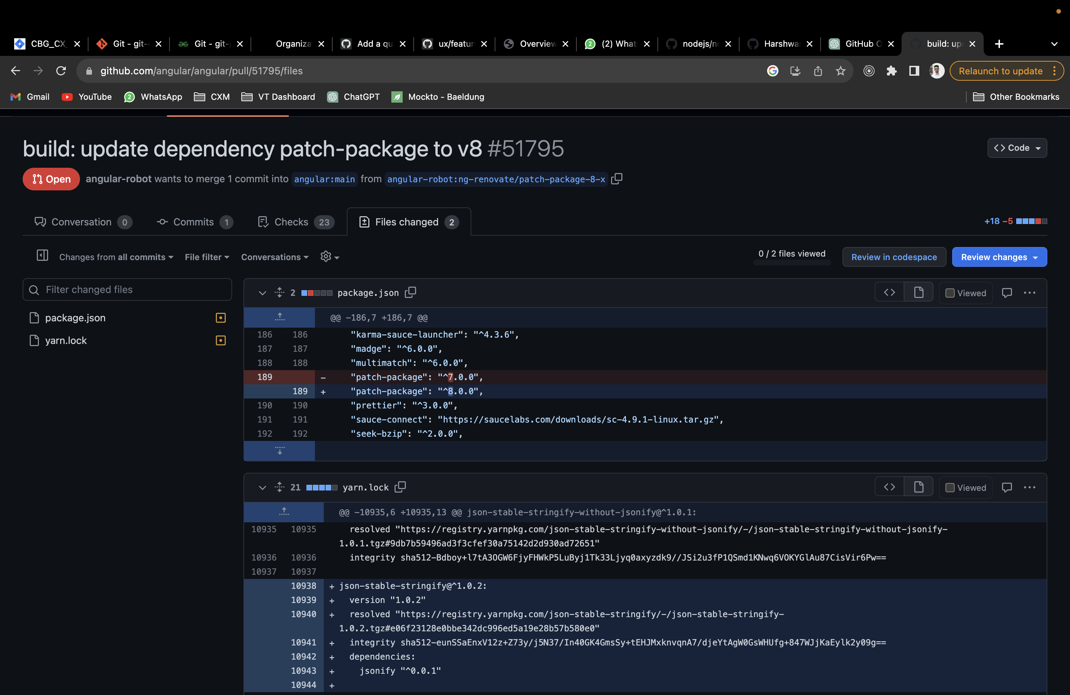

4.

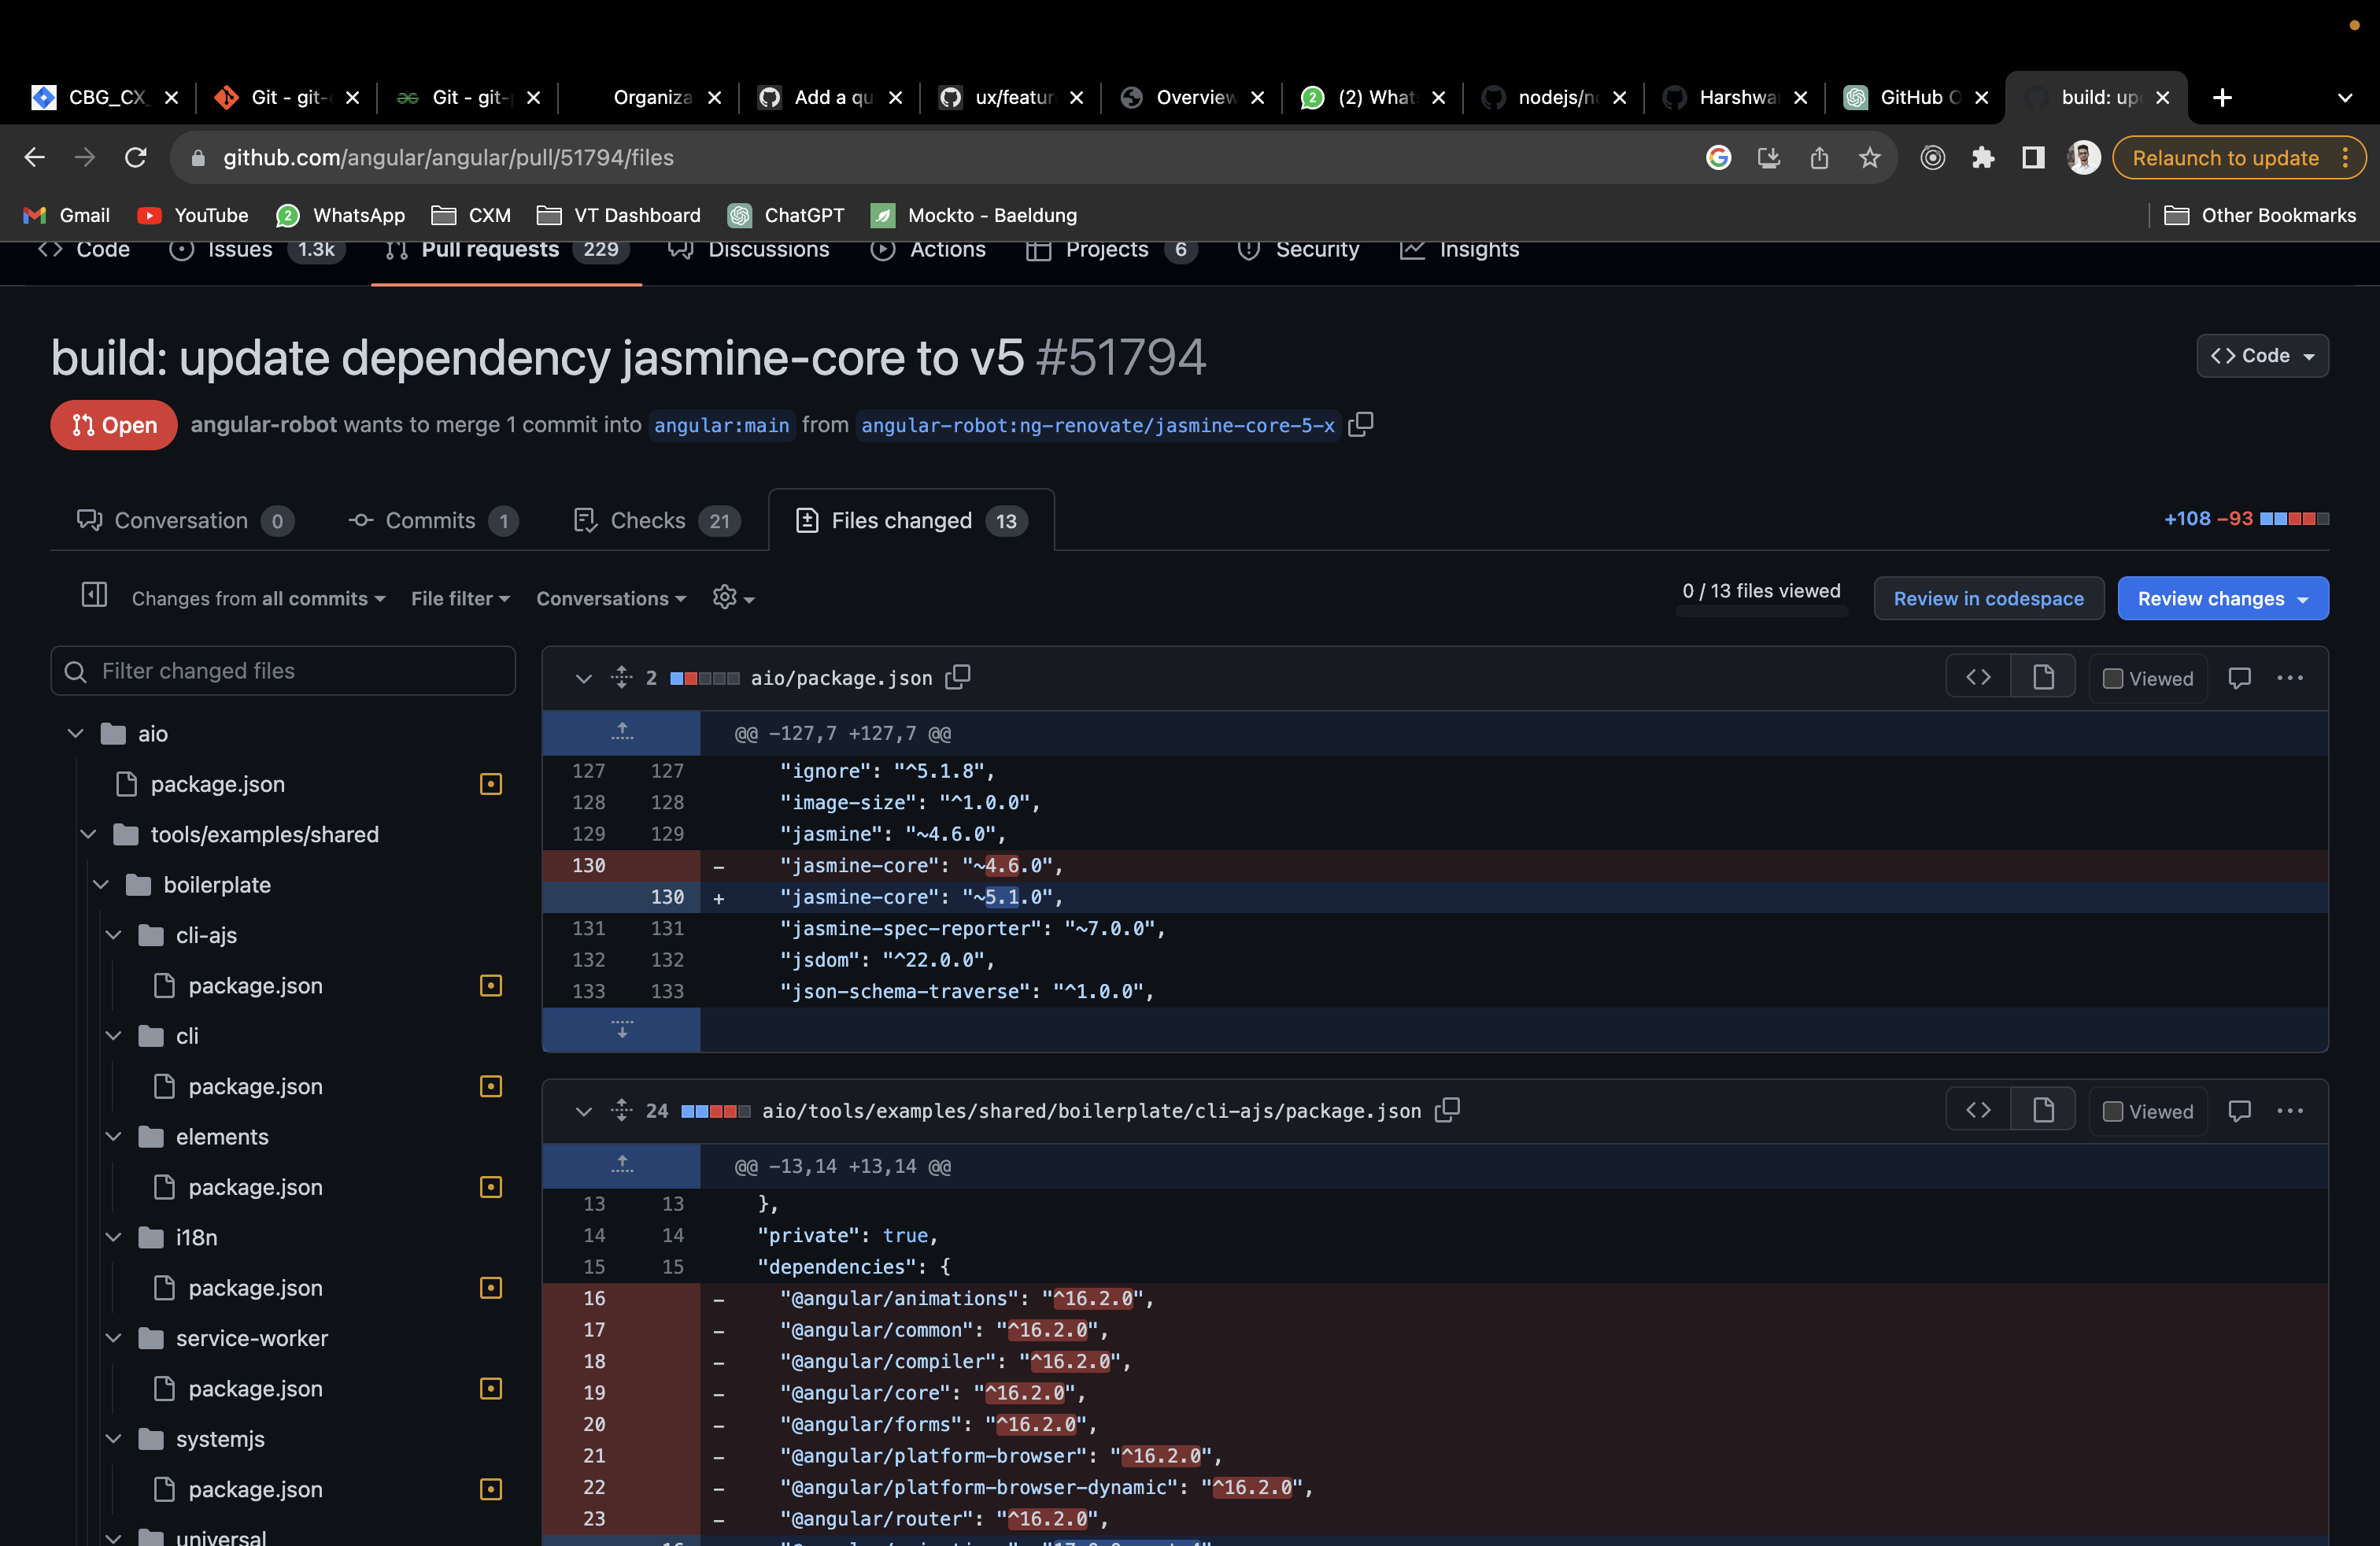

5. 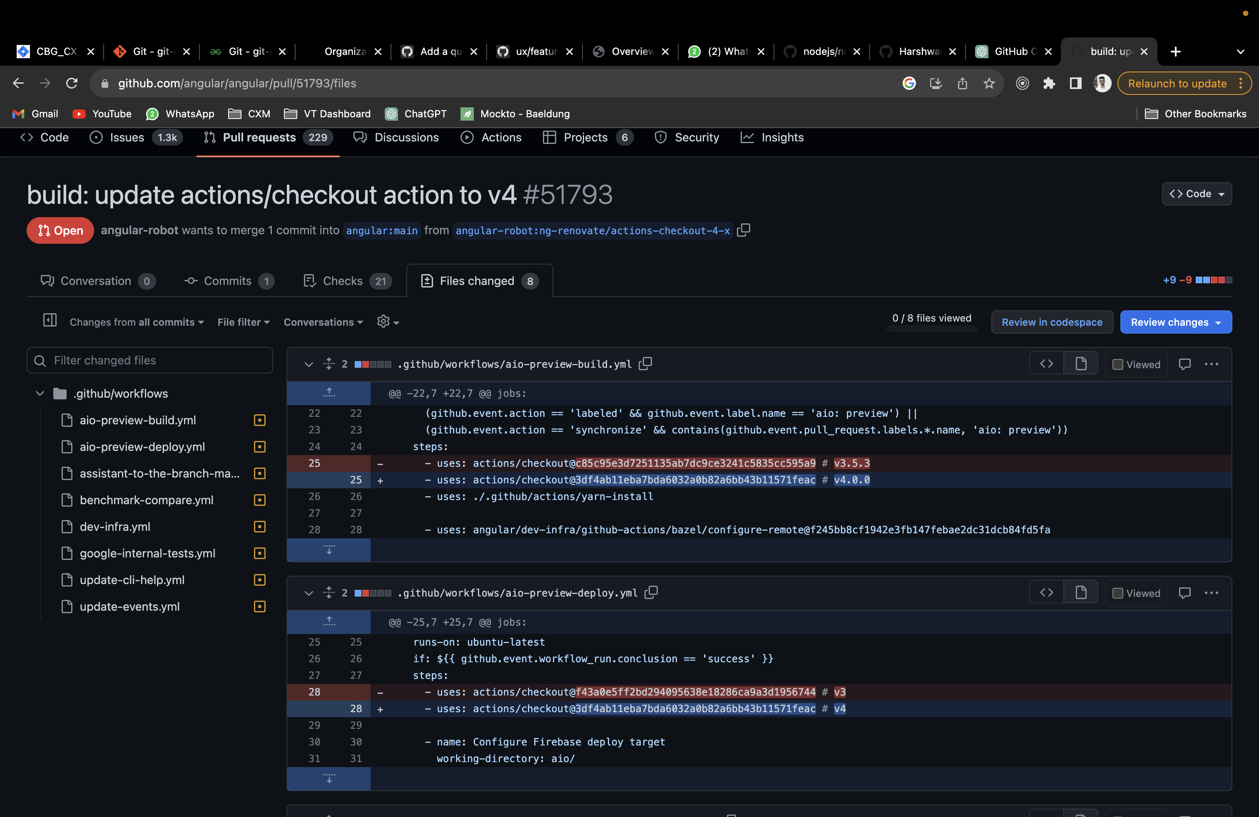

Closed:-

1. 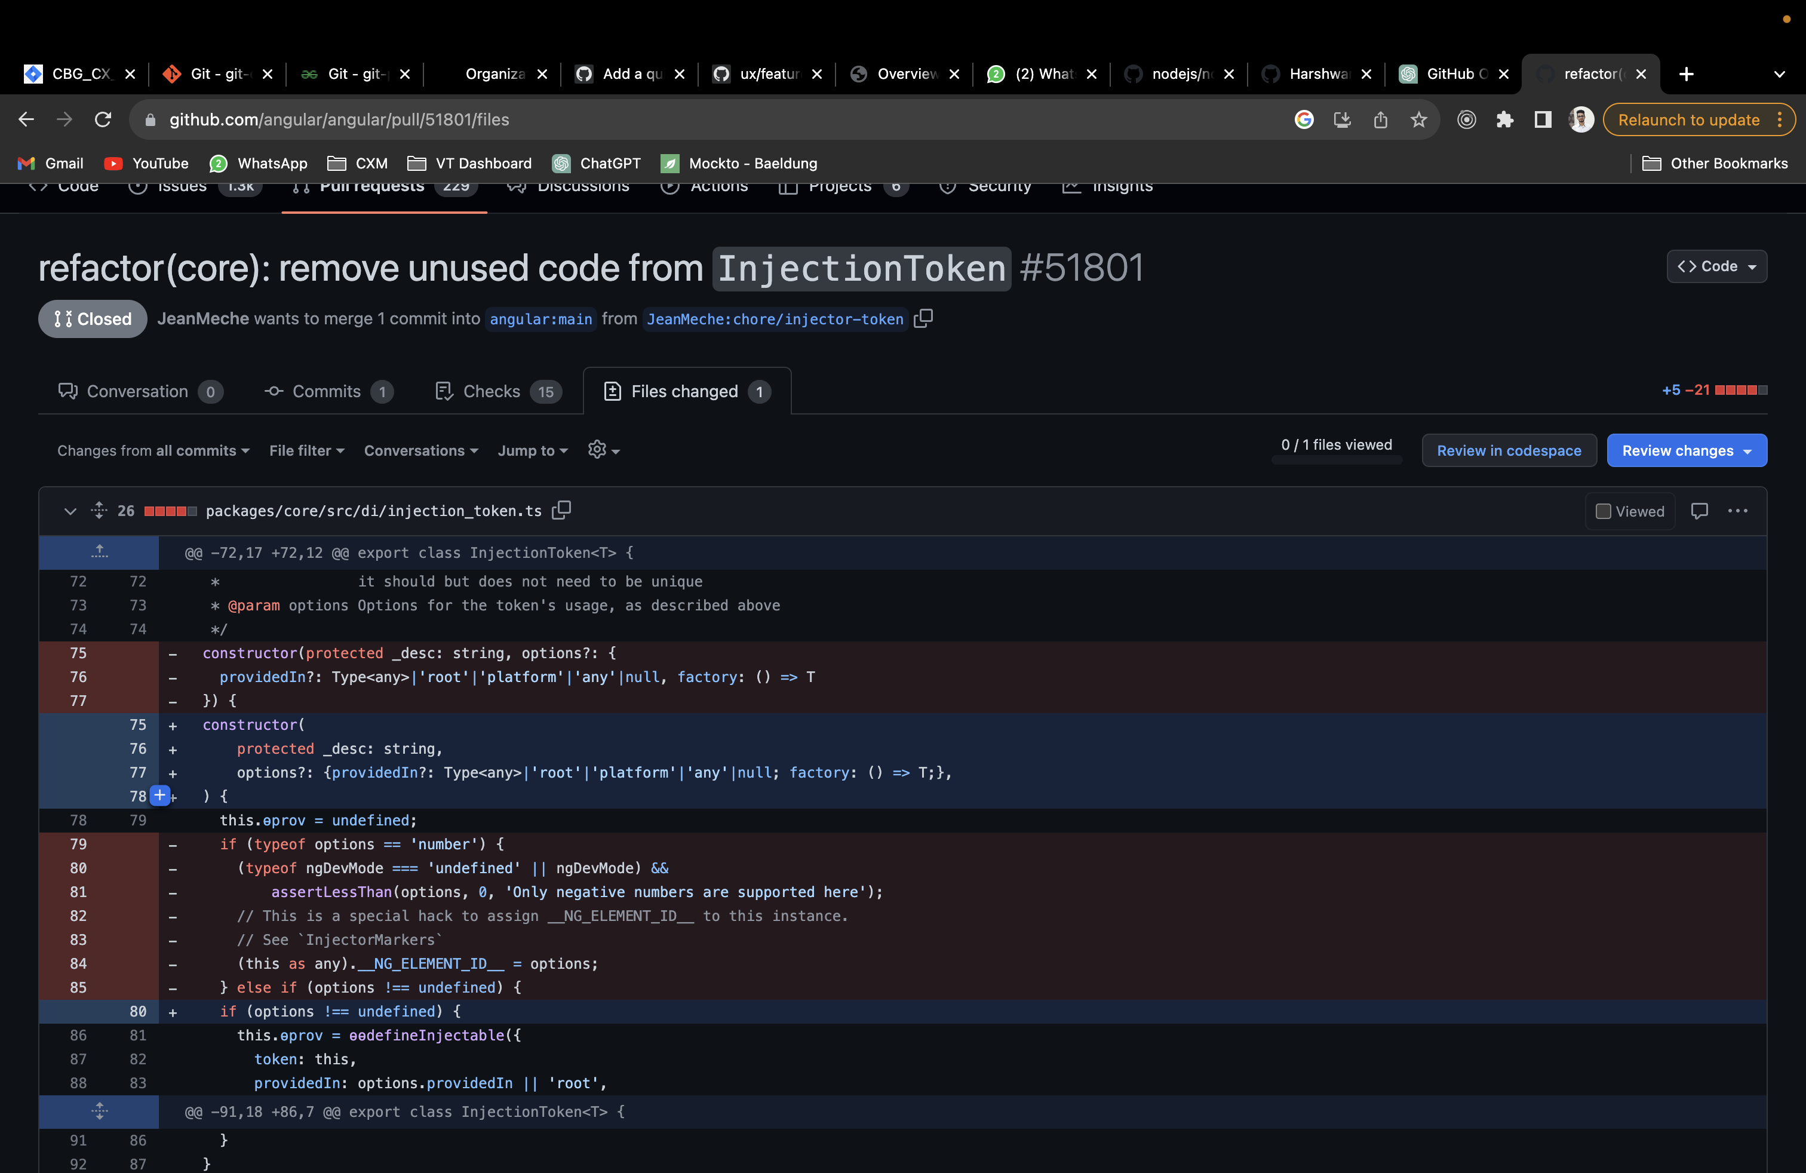

2.

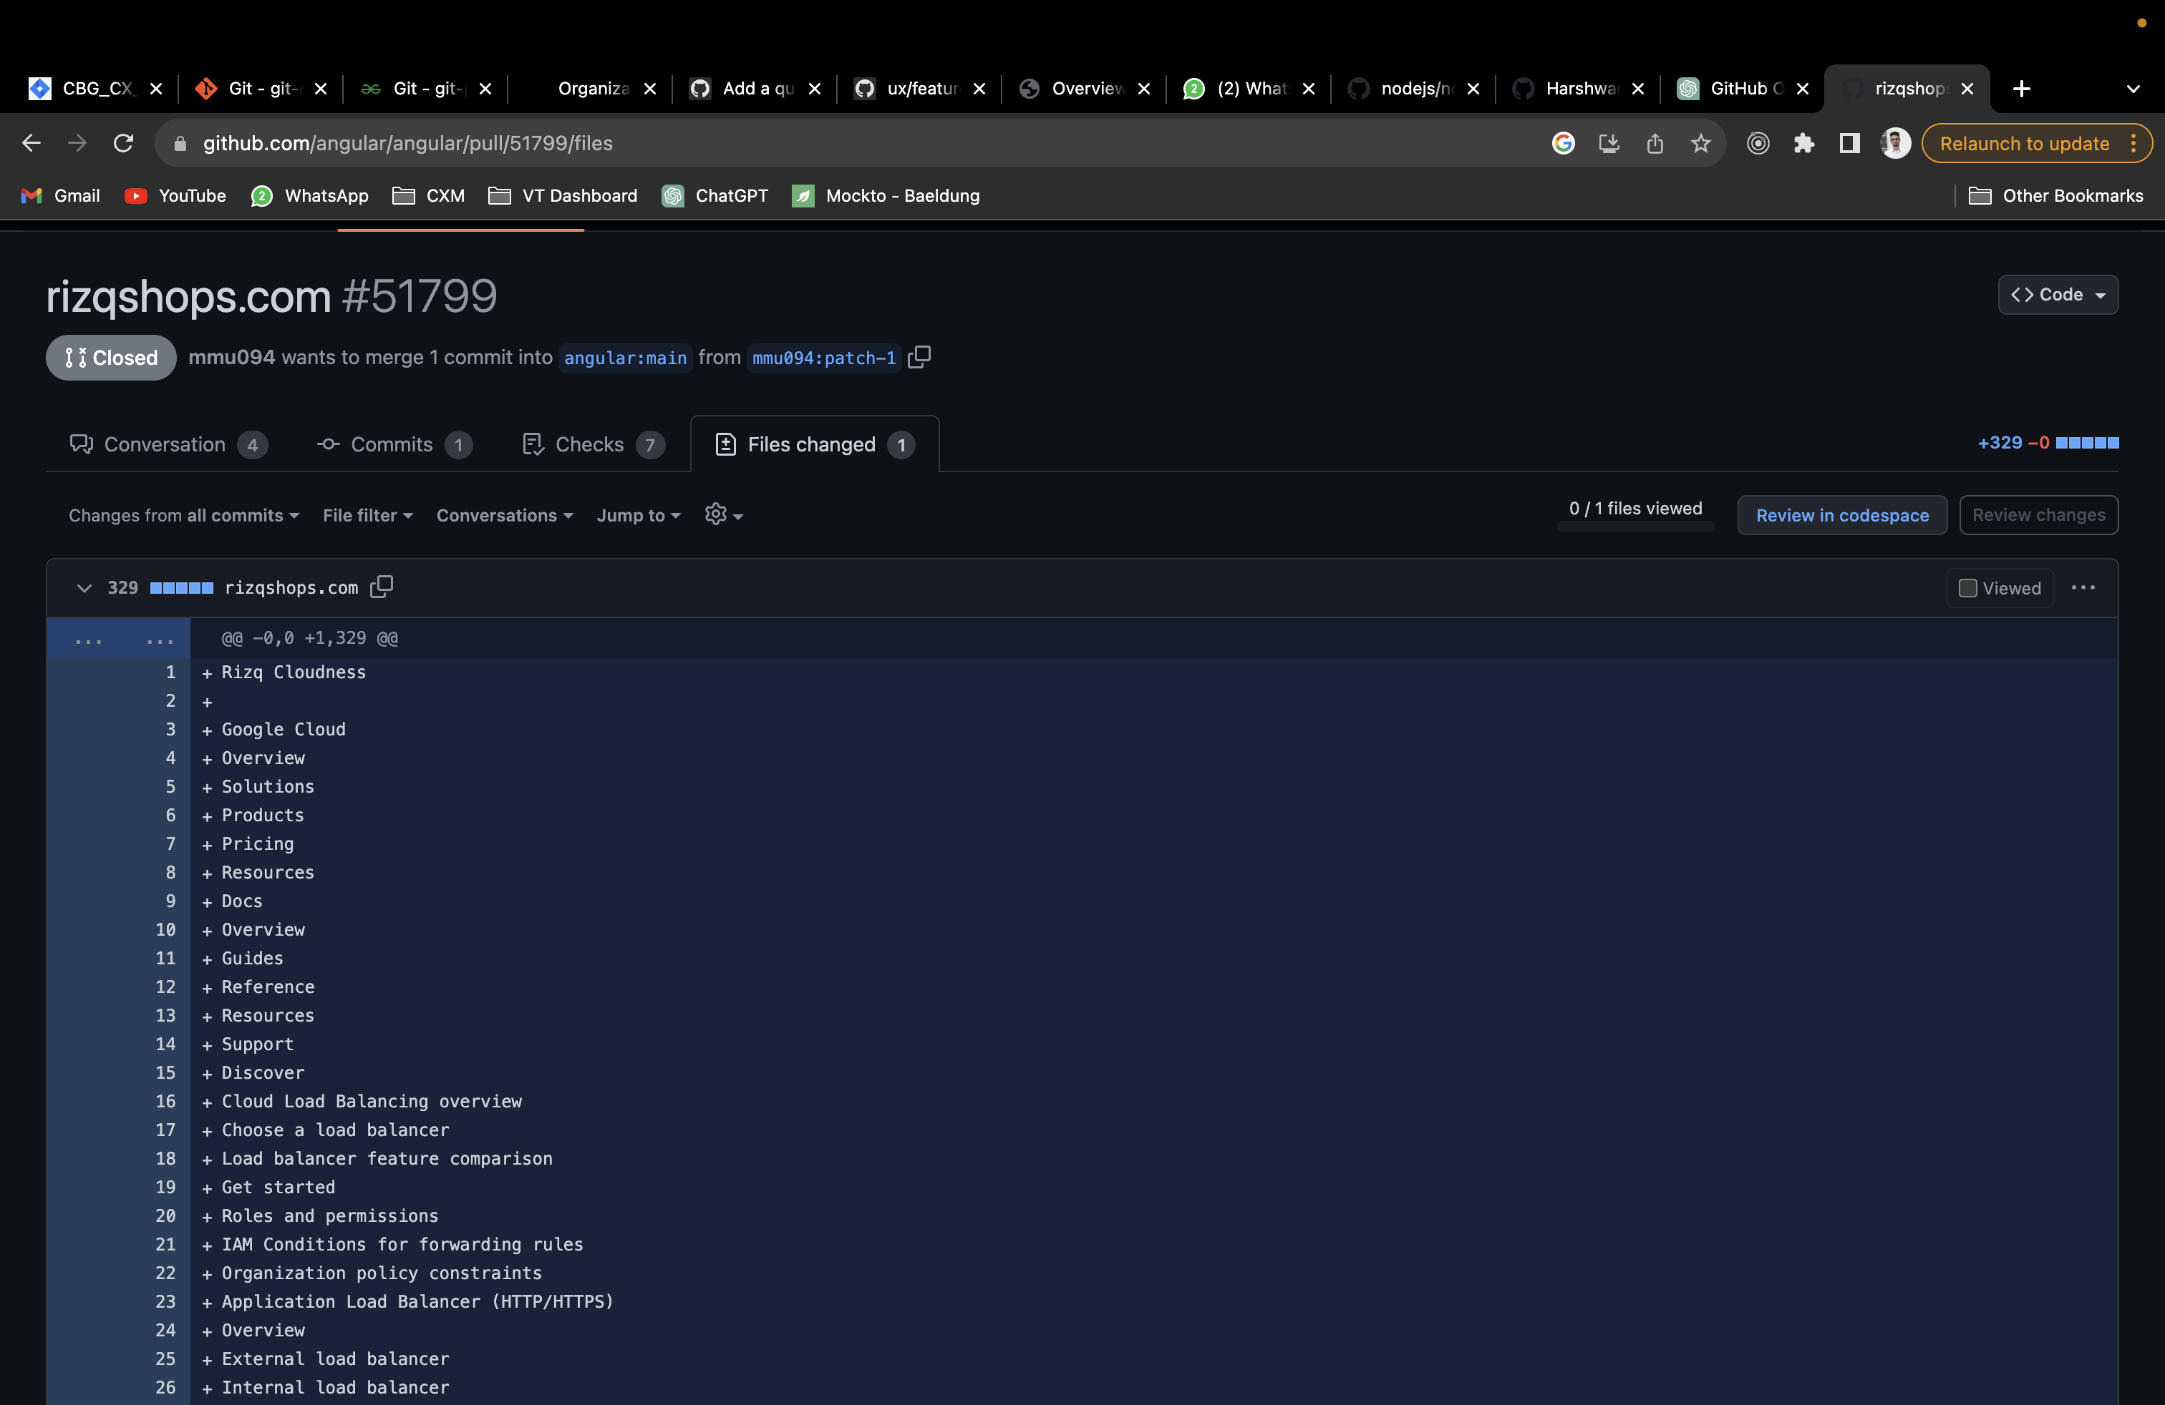

3.

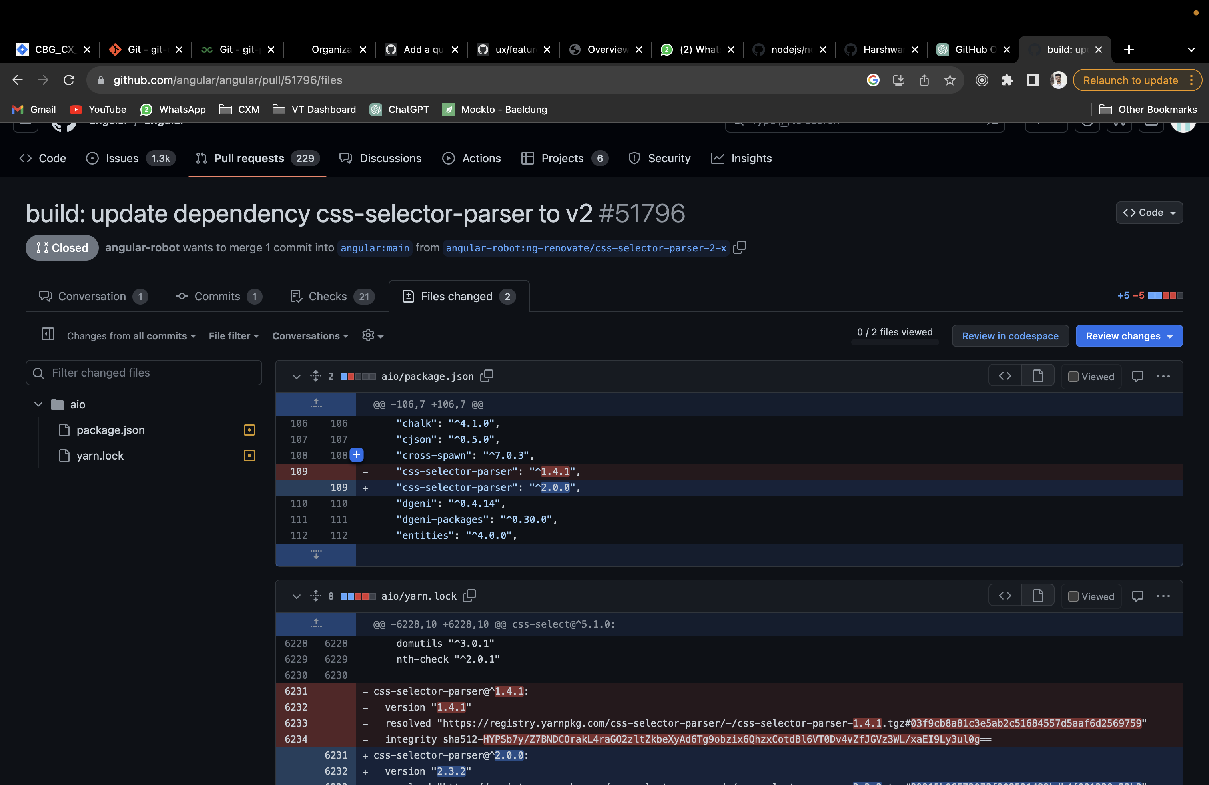

4.

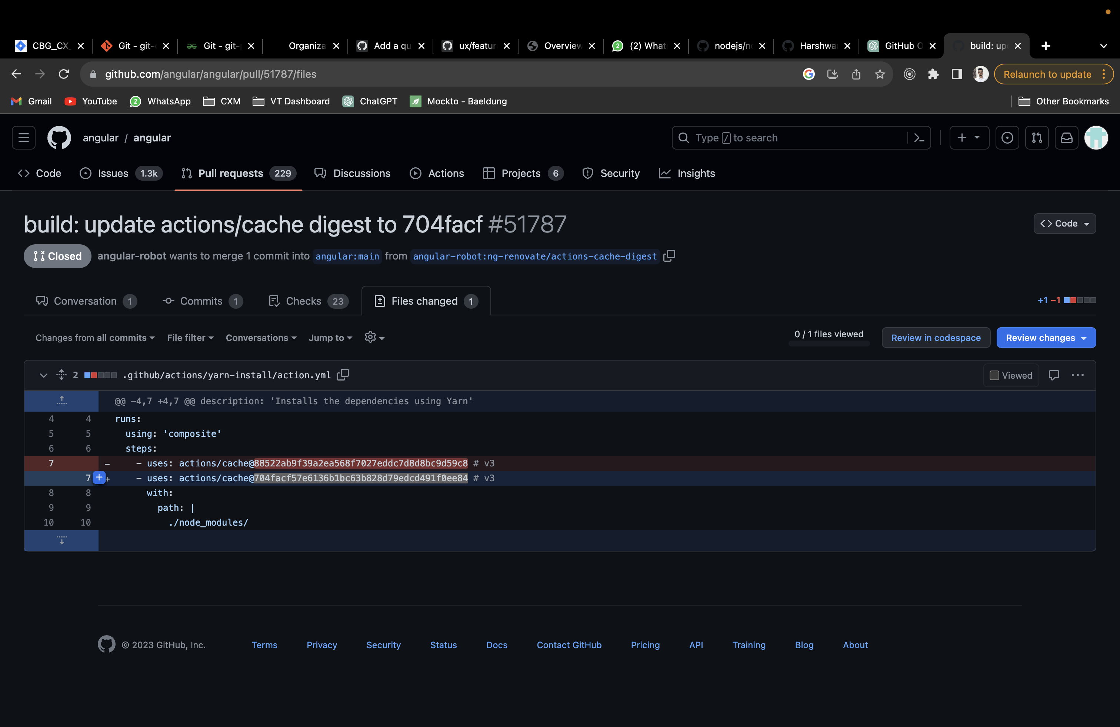

5.

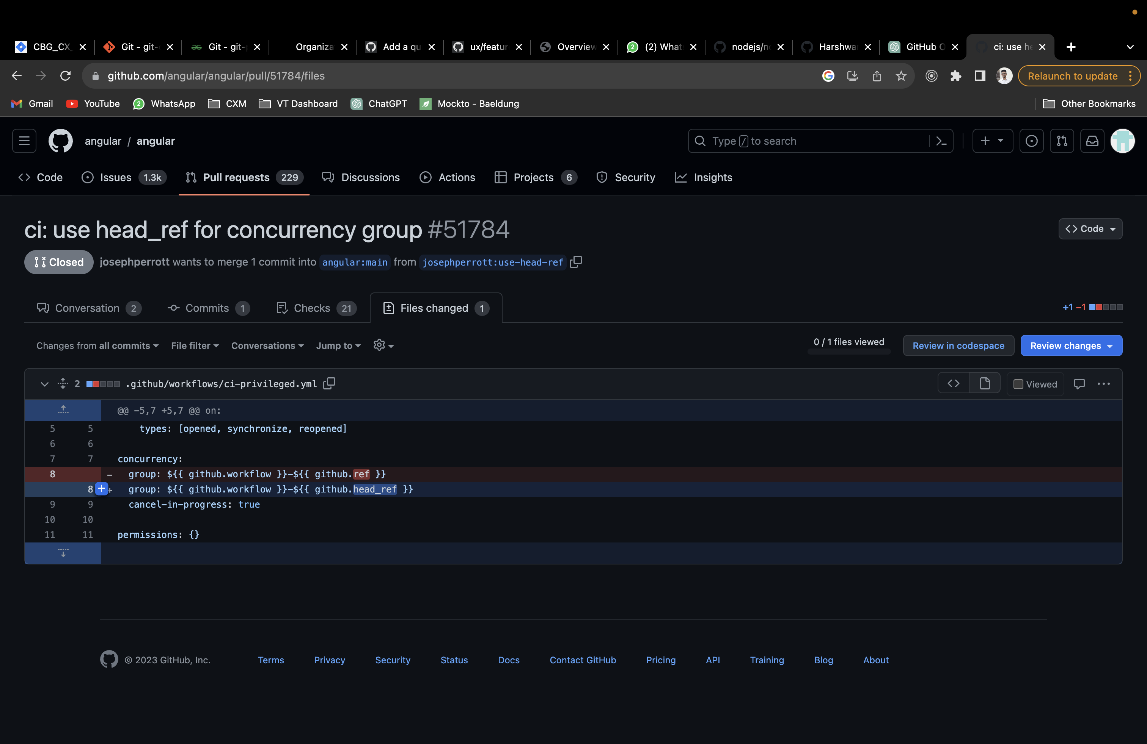

Number of forks of the repo: 24.2k